ITR–2

ITR-2 is an Income Tax Return form, for Individuals and HUF, not carrying any Business or Profession.

Who is Eligible to file ITR?
ITR2 can be filed by Individuals or HUF who:
- Are not eligible to file ITR1
- Have the following incomes:
  - IncomefromSalary/Pension
  - IncomefromHouseProperty
  - IncomefromCapitalGains
  - IncomefromOthersources(includingwinningfrom Lottery,Horserace)
  - ForeignAssets
  - AgricultureincomemorethanRs.5000
- Do not have any kind of income from the head income from Business or Profession
- Have the income of the other person clubbed to his income.
STRUCTURE OF THE FORM
PARTA
- GENERAL INFORMATION
- COMPUTATION OF TOTAL INCOME & TAXPAYABLE
PARTB

ITR 2 Form is bifurcated into two parts, that is, Part A and Part B. While Part A contains general information, Part B comprises the computation of total income and the tax payable on the total earnings. Along with these two parts, the formal so includes various schedules such as details of income from salary, income from house or property, income from capital gains, income from other sources, etc.

PARTA-GENERALINFORMATION

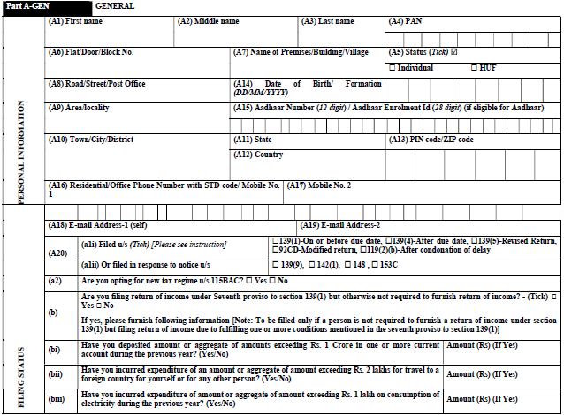

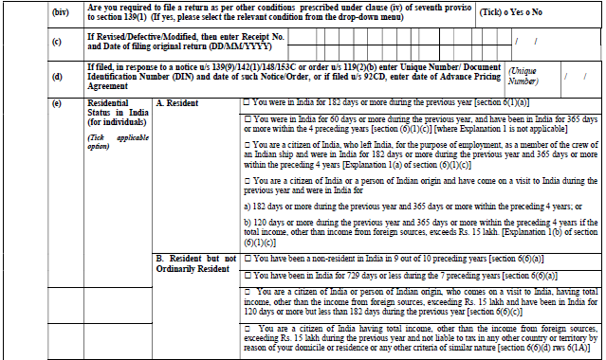

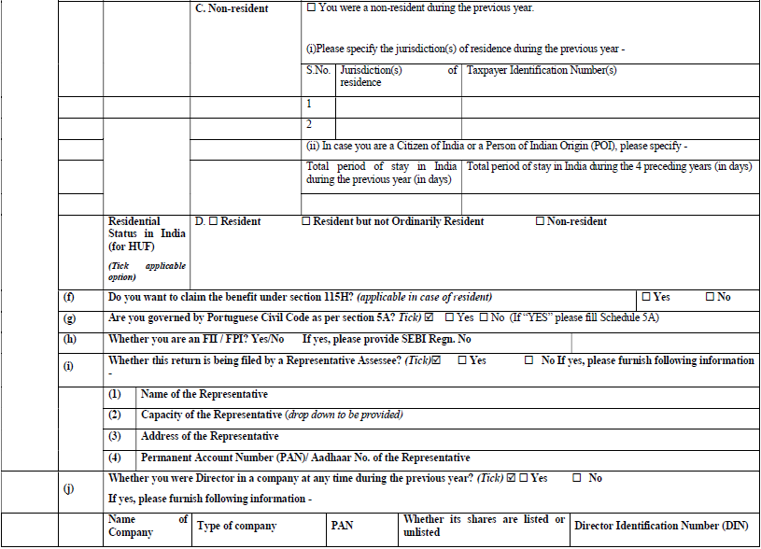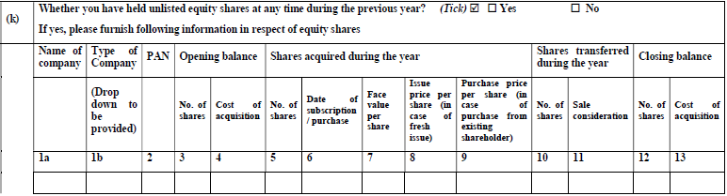
The cells of the Part A is described below:
- A1 – A19 : These cells contain the Basic details of the assessee similar to the Part 1 of every other ITR form.
- A20 :
- To mention whether the return is filed as per section 139 or filed in response to a notice or order under section 139(9), 142(1), 148 or 153C.
- (Sec 153C provides for the assessment of income of any other person where AO is satisfied that any valuable article seized (or requisitioned) belongs to, any books of account or documents seized (or requisitioned) pertain to or any information contained therein relates to such other person (not the one in whose case the search or requisition proceedings are initiated)
- Also given an option to move in to new tax scheme.(115BAC)
- Needs to select whether it is furnished as per the seventh proviso of Sec139(1)

- Date of Original return is to be filled, if there turn is revised, defective, modified.
- Enter the Unique number /Document Identification number and date of notice received under section 139(9)/148/153C or order under Section 119(2)(b)
- Residential status of the assessee is mentioned here
- Option to claim benefit under section 115H (115H-Benefit under Chapter to be available in certain cases even after the assessee becomes resident)
- Need to select whether the assessee is governed by Portuguese Civil Code aspersection 5A.
- Provide SEBI Regn. No if the assessee is Foreign Institutional Investor (FII) or Foreign Portfolio Investor (FPI)
- Details of the representative assessee is to be filled, whether it is filed by his representative.
- If the assessee is a Director of any Firm, need to fill the PAN of the company and DIN of the assessee.
- Details of the unlisted equity shares, which is held during the previous year are filled in this cell.

Part A of ITR 2 also includes various schedules for the computation of income from the following heads, i.e Salary, House Property, Capital Gains and Other Sources.

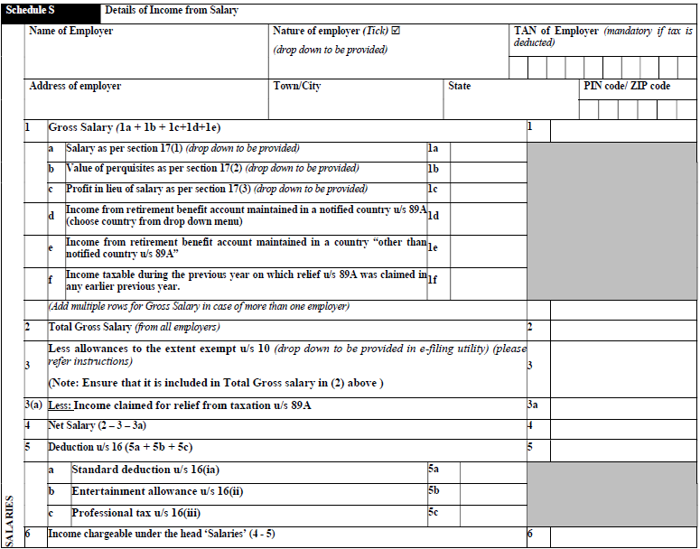
INCOME FROM SALARY

The above table shows, the details of Income from Salary. The basic details of the employer, TAN of the employer is filled in the former cells. While the latter cells contains particulars for the calculation of Total Income after all the allowances and deductions under section 16
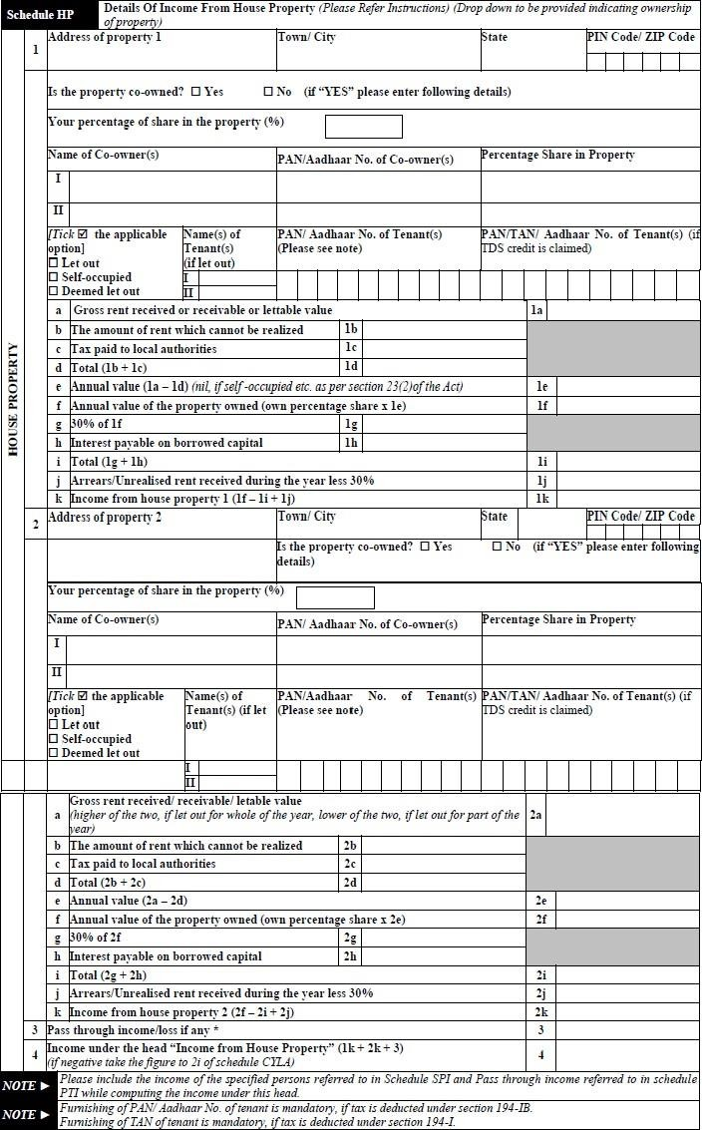

INCOME FROM HOUSE PROPRTY

The Schedule given in the previous page, is used for the computation of Income from house Property. The details of the Property, Tenant and the co-owner is to be filled in their respective cells. This schedule follows the usual procedures, in calculating, Income from House Property. Standard deduction u/s24A,and interest payable etc. are reduced from the Net Annual Value to compute the Income from house Property.

- INCOME FROM CAPITALGAINS
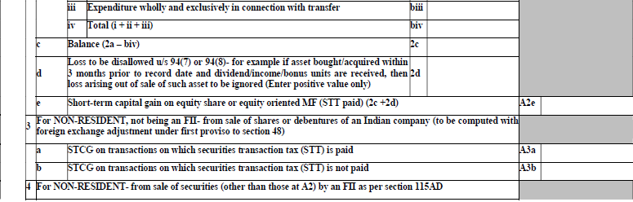
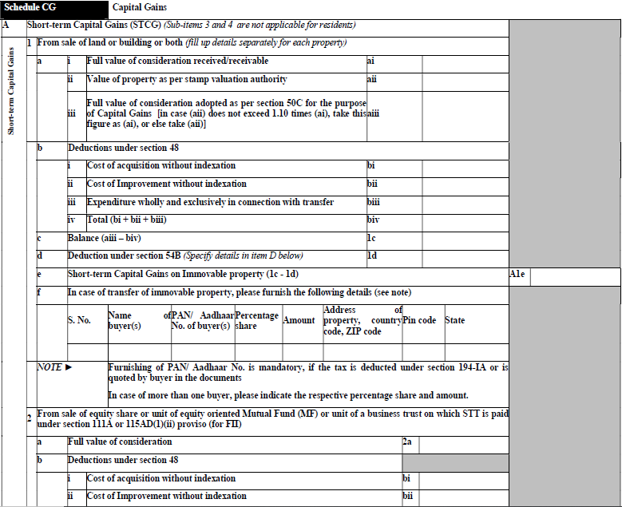

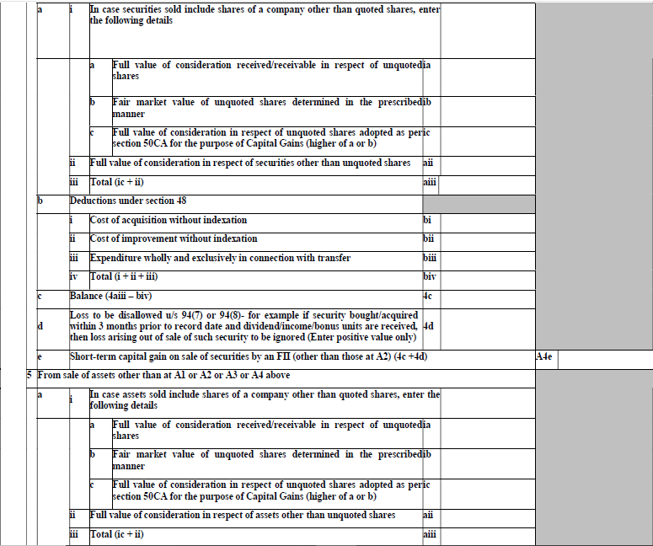
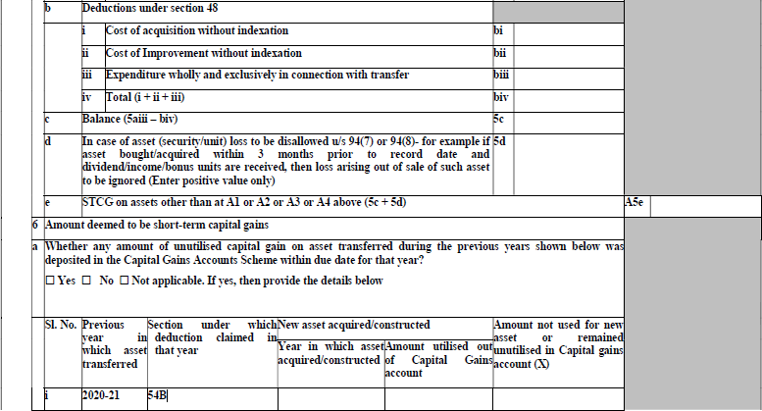
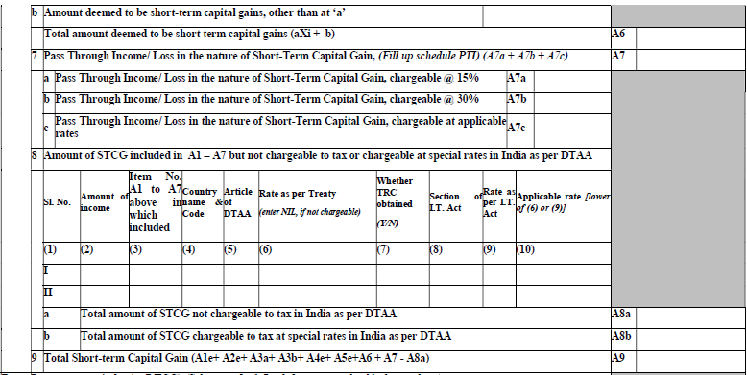

SHORT TERM CAPITAL GAINS
The following sections are mentioned in the Schedule for calculation of Short term Capital gain:
- Sale of Land or Building or both
  - Short term loss in the case of sale of land and building is computed considering section 50 C and deducting available deductions. Furnishing PAN/ Aadhar is mandatory, in case Tax is deducted u/s194IA
Section 50C: Section 50C deals with the computation of capital gain on sale of land or building or both which is held as capital asset. As per this section, the value of sale consideration should not be less than the stamp duty value which is assessed by the Stamp Valuation Authority
- Sale of Equity share, Equity oriented Mutual Fund or unit of business trust on which STT is paid u/s 111A or 115AD
  - Section 111A – applicable in case of STCG arising on transfer of equity shares or units of equity oriented mutual-funds (*) or units of business trust, which are transferred on or after 1-10-2004 through a recognised stock exchange and such transaction is liable to securities transaction tax (STT).
  - Section 115 AD - Tax on income of Foreign Institutional Investors from securities or capital gains arising from their transfer.
Disallowed Loss u/s 94(7) or 94(8) (dividend stripping and Bonus stripping) are added back, to compute the Short term Gain.
- Sale of Shares or Debentures, of an Indian Company by a Non-Resident, not being an FII (Foreign Institutional Investor)
- Sale of Shares and debentures by a Non-Resident, being an FII, as per Sec 115AD.
- From Sale of Assets other than those mentioned above.
- Here mentions the amount deemed to be a short term capital gain. Details of any unutilized capital gain, if transferred need to be furnished in the schedule in the cell6 (a).Amount other than that in which is deemed to be a short term gain is to be mentioned in cell6(b).

(Section54B of Income-tax Act provides exemption in respect of capital gain arising on sale of urban agricultural land)
- Pass Through Income/Loss in the nature of Short Term Capital Gain is mentioned in three rates: 15%, 30% and applicable rates in cells A7a ,A7b and A7crespectively.
- Amount of STCG mentioned in A1-A7, but are not chargeable to Tax or chargeable at Special rates, are mentioned in this section.
- Total Short Term Capital Gain: All the above sections are summed up to get income from the head Short Term Capital Gains.

LONG TERM CAPITAL GAINS

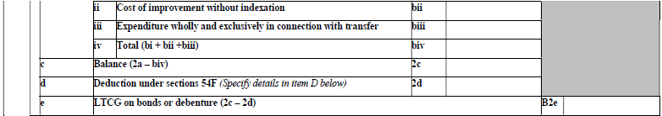

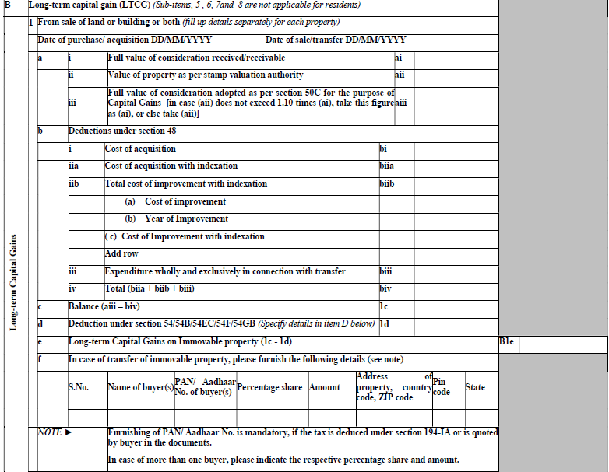

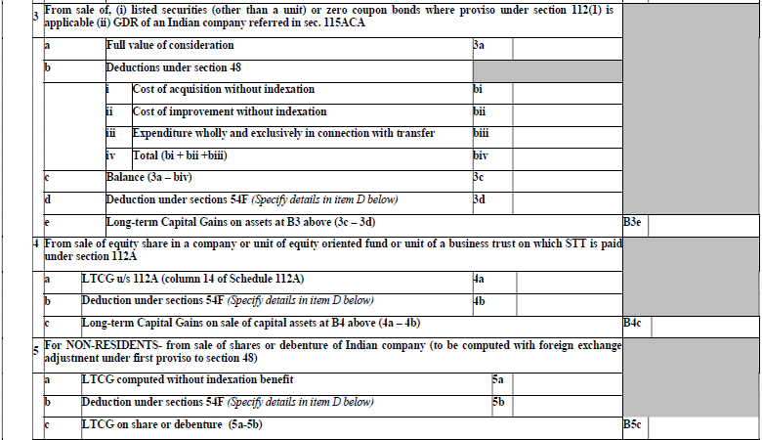
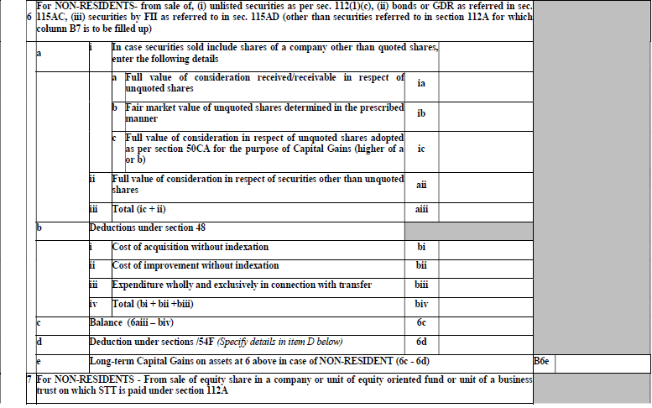

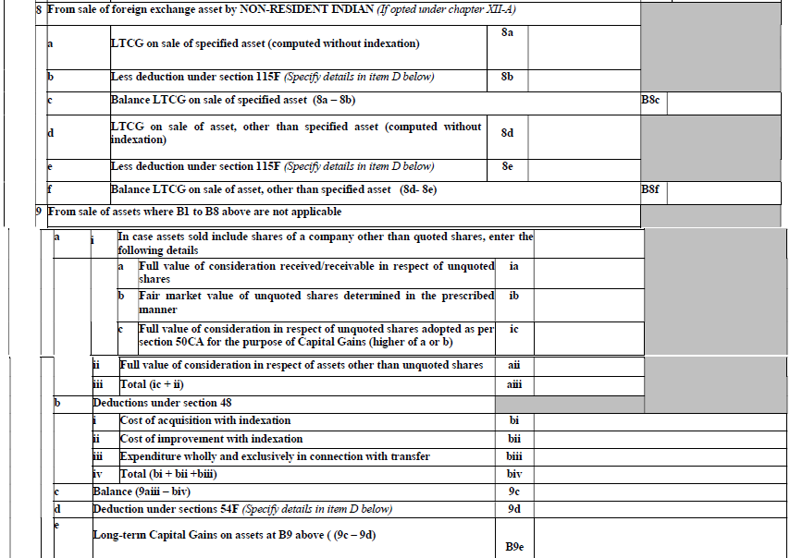
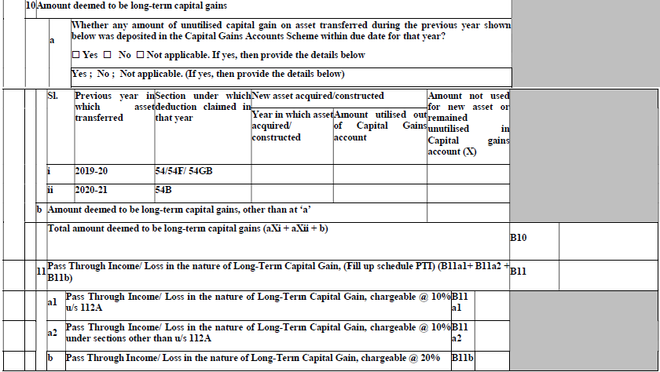

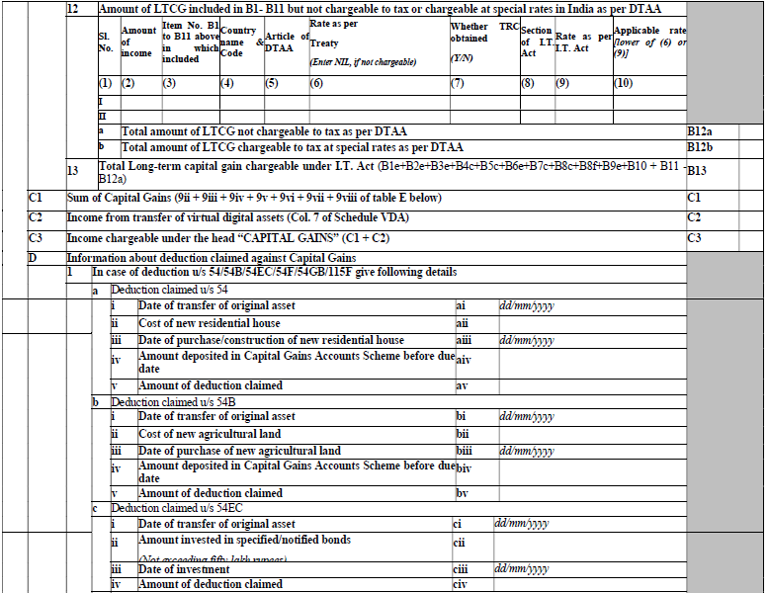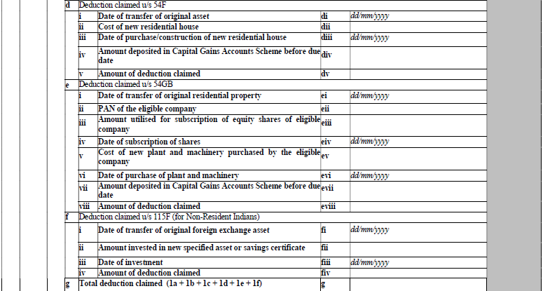
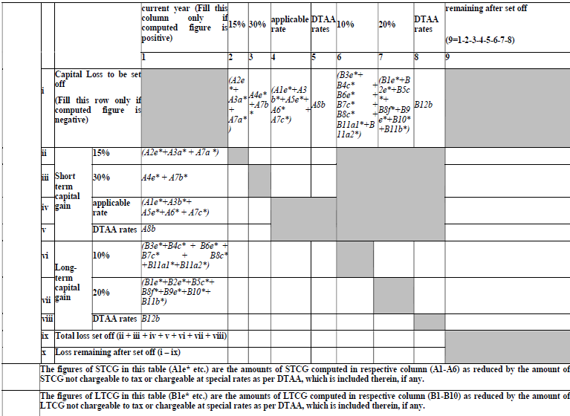
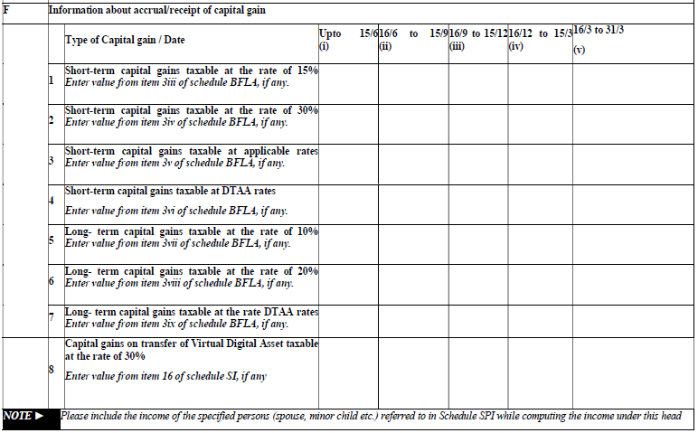

Long Term Capital Gain
Any capital asset held by the taxpayer for a period of more than 36 months immediately preceding the date of its transfer will be treated as long-term capital asset.
However, in respect of certain assets like shares (equity or preference) which are listed in a recognized stock exchange in India (listing of shares is not mandatory if transfer of such shares took place on or before July 10, 2014), units of equity oriented mutual funds, listed securities like debentures and Government securities, Units of UTI and Zero Coupon Bonds, the period of holding to be considered is12 months instead of 36 months.

Note
Period of holding to be considered as 24 months instead of 36 months in case of unlisted shares of a company and immovable property being land or building or both
Following sections are mentioned in the schedule of short term capital gain;

Deduction under section 54
Under Section 54 the Income Tax Act, an individual or HUF selling a residential property can avail tax exemptions from Capital Gains if the capital gains are invested in purchase or construction of residential property.
Tax payers such as partnership firms, LLP‘s, companies or any other association or body cannot claim tax exemption under section 54. The conditions that need to be satisfied to avail the benefit of the said section are as follows:
- Asset must be classified as a long-term capital asset.
- The asset sold is a Residential House. Income from such a house should be chargeable as Income from House Property.
- The seller should purchase a residential house either1 year before the date of sale/transfer or 2 years after the date of sale/transfer. In case the seller is constructing a house, the seller has an extended time, ie. the seller will have to construct the residential house within 3 years from the date of sale/transfer. In case of compulsory acquisition, the period of acquisition or construction will be determined from the date of receipt of compensation (whether original or additional compensation)
- The new residential house should be in India. The seller cannot buy or purchase a residential house abroad and claim the exemption.

Deduction Under Section 54B
Deduction under section 54B can be claimed in respect of capital gains arising on transfer of capital asset, being agricultural land (may be long-term or short-term). This benefit is available only to an individual or a HUF. The land should be used for agricultural purpose at least for two years.

Deduction under Section 54EC
Section 54EC states that if the profit made on sale of a long-term capital asset – whether an immovable property or shares and stocks – is invested by the taxpayer in 'long-term specified assets within 6 months of the sale, then the capital gains are exempt from taxation.

Deduction under section 54F
Section 54F of the Income Tax Act, 1961 is a section that allows tax exemption on the long term capital gains earned from selling a capital asset, other than a house property. So, if you sell a capital asset like shares, bonds, jewellery, gold, etc.

Deduction under section 54GB
As per section 54GB, any capital gain arising to an individual or HUF from the transfer of a long-term capital asset being a residential property (a house or plot of land) shall be exempt proportionate to the net consideration prices of invested in the subscription of equity shares of a eligible company before the due date of furnishing the return of income under section.

Section 112
Under Section112 of Income Tax Act, an assesses is required to pay a tax at the rate of 20% or 10% after and before indexation respectively on the capital gain earned by him on long term capital assets defined under Section 2(29A) of the ITAct,1961.
Section115ACA
Tax on income from global depository receipts purchased in foreign currency or capital gains arising from their transfer
Applicable – Resident individual and an employee of an Indian company engaged in specified knowledge based industry or service, or an employee of its subsidiary engaged in specified knowledge based industry or service

Section115F
This tax regime applies to a Non-resident Indian. It means a non-resident individual who is a citizen of India or a person of Indian origin. This section provides for complete exemption of long-term capital gains on the transfer of foreign exchange assets in certain cases. Thus, it is provided that where, in the case of a non-resident Indian, any long-term capital gains arising from the transfer of a foreign exchange asset and the non-resident Indian has within a period of six months from the date of such transfer invested or deposited the whole or any part of the net consideration in any specified asset or in account referred to in Section 10(4) or in Savings Certificates as per Section l0(4B), then no tax is payable. Thus, if the amount of the net consideration is invested in the purchase of a new asset as specified earlier, then no income tax is leviable on such long-term capital gains.

ScheduleofSection112A

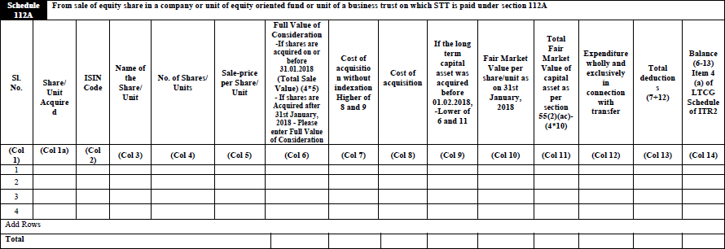

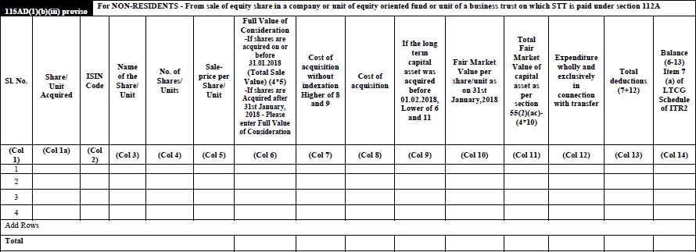

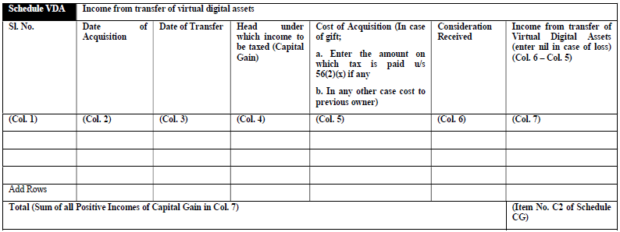

Section112A

- Notwithstanding anything contained in section 112, the tax payable by an assessee on his total income shall be determined in accordance with the provisions of sub-section(2),if-
  - The total income includes any income chargeable under the head "Capital gains";
  - the capital gains arise from the transfer of a long-term capital asset being an equity share in a company or a unit of an equity oriented fund or a unit of a business trust;
  - securities transaction tax under Chapter VII of the Finance(No.2)Act,2004(23of2004)has,—
    - in a case where the long-term capital asset is in the nature of an equity share in a company, been paid on acquisition and transfer of such capital asset; or
    - in a case where the long-term capital asset is in the nature of a unit of an equity oriented fund or a unit of a business trust, been paid on transfer of such capital asset.
- The tax payable by the assessee on the total income referred to in sub-section(1)shall be the aggregate of—
  - The amount of income-tax calculated on such long-term capital gains exceeding one lakh rupees at the rate of ten percent.
  - The amount of income-tax payable on the total in come as reduced by the amount of long-term capital gains referred to in sub-section (1) as if the total income so reduced were the total income of the assessee:

To summarize Long-term capital gain arising from sale of specified securities is though included in total income but no tax shall be charged thereon if the aggregate amount of such gain during the year doesn't exceed Rs. 1,00,000. Where the amount of long-term capital gain from specified securities exceeds Rs. 1,00,000, the excess amount is chargeable to tax at the rate of 10%.

In general, long-term capital gain arising from transfer of a capital asset is chargeable to tax at the rate of 20%.However, where total income of an assessee includes long-term capital gain arising from transfer of specified securities, no tax shall be charged on such long-term capital gain if the aggregate amount of such gain during the year is up to Rs. 1,00,000. Where the amount of capital gain exceeds Rs. 1,00,000, the excess amount is chargeable to tax at concessional rate.

The concessional tax rate is applicable in respect of long-term capital gains only when such gain arises from transfer of following securities (hereinafter referred to as 'specified securities'):-

(a) Equity shares; or

(b) Units of equity oriented mutual fund; or

(c) Units of business trust

Schedule VDA (Virtual Digital Assets):
​
According to Section 2(47A)"virtual digital asset" means—

(a) any information or code or number or token (not being Indian currency or foreign currency), generated through cryptographic means or otherwise, by whatever name called, providing a digital representation of value exchanged with or without consideration, with the promise or representation of having inherent value, or functions as a store of value or a unit of account including its use in any financial transaction or investment, but not limited to investment scheme; and can be transferred, stored or traded electronically;

(b) a non-fungible token or any other token of similar nature, by whatever name called;

(c) any other digital asset, as the Central Government may, by notification in the Official Gazette specify:

Provided that the Central Government may, by notification in the Official Gazette, exclude any digital asset from the definition of virtual digital asset subject to such conditions as may be specified therein.

Explanation.—For the purposes of this clause,—

(a) "non-fungible token" means such digital asset as the Central Government may, by notification in the Official Gazette, specify;

(b) the expressions "currency", "foreign currency" and "Indian currency" shall have the same meanings as respectively assigned to them in clauses (h), (m) and (q) of section 2 of the Foreign Exchange Management Act, 1999 (42 of 1999);]

Every transfer of virtual digital assets on or after 01-04-2022 shall be covered under this scheme. Further, Section 194S requires the deduction of tax from the payment of consideration on the transfer of VDA.

The person who are having the income from transfer of Virtual digital Assets shall mention the details such as ​ date of acquisition, date of transfer, head under which income is to be taxed, cost of acquisition in case of gift and consideration received.

SCHEDULE OF INCOME FROM OTHER SOURCES
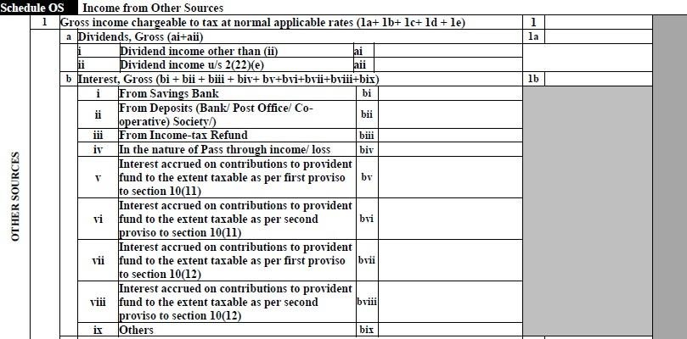

SECTION 2(22)(e)- Deemed Dividend:-
As per Section 2 (22) e, when a closely held company, gives a loan or extends an advance to the respective personnel:
- A shareholder who holds a minimum of 10 percent of the voting rights, and is the beneficial owner of shares. However, it is important that the shares held are not entitled to a dividend rate‘s fixed rate.
- When such shareholder is substantially interested towards any business concern.
- For such shareholder‘s individual benefit.
- To a specific extent on behalf of such shareholder.
Such payments would be deemed as a dividend under Section 2(22).
SECTION 10(11)-
Provisions of section10(11)fully exempt the amount received from the Statutory Provident Fund .It also fully exempts the amount received from any other provident fund ,which is set up and notified by the Central Government.
SECTION 10(12)-Provisions of section 10(12) exempt the accumulated balance, due and payable, to the employee participating in the Recognized Provident Fund.

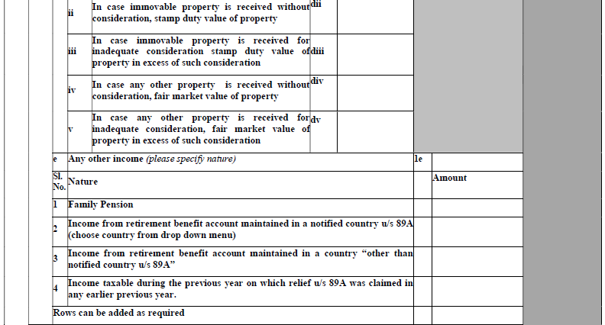


Section 56(2)(x)-Section56 (2) (x) provides that following receipts shall be taxed in hands of any person where received from any person or persons on or after 01.04.2017 during any previous year.
- Any sum of money exceeding Rs.50000 in aggregate without consideration.
- Any immovable property received without consideration, if the stamp duty value of such property exceed Rs.50000.
- Any immovable property received for a consideration which is less than the stamp duty value of the property by an amount exceeding Rs.5000/-.
Section 89(A)- When a non-resident becomes a resident in India, the income in his foreign retirement benefits account is chargeable to tax in India on an accrual basis. However, some countries tax such an amount at the time of receipt. Due to a mismatch in the year of taxability of such income in retirement funds, the taxpayers (generally non-residents who have permanently returned to India) face difficulties in availing of the foreign tax credit in respect of tax paid outside India on such income.Section 89A, inserted with effect from the assessment year 2022-23, removed the aforesaid difficulty by providing that the income of a specified person from the specified account shall be taxed in such manner and for such year as may be prescribed by rules
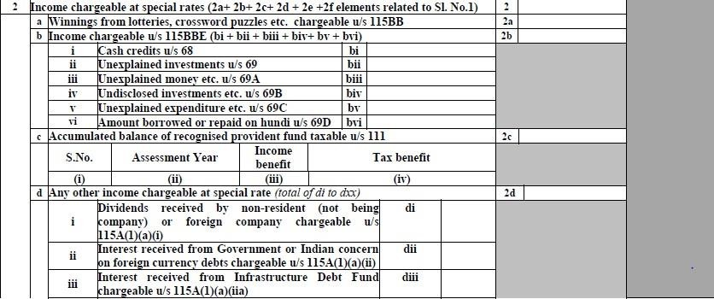

Section 115BB- Any winnings from a game of chance are taxed at special rates under section 115BB. Income arising from lottery or crossword puzzles, race including horserace, card game, or any other game of the same sort would be taxed at a flat rate of 30%.
115BBE-As per Section 115BBE, income tax shall be calculated at 60% where the total income of assessee includes following income:
Income referred to in Section 68, Section 69, Section 69A, Section 69B, Section 69C or Section 69D and reflected in there turn of income furnished under Section 139; or
Which is determined by the Assessing Officer and includes any income referred to in Section 68, Section69, Section69A, Section69B, Section69C or Section69D, if such income is not covered under clause (a)
Section 68 - As per section 68, any sum found credited in the books of a taxpayer, for which he offers no explanation about the nature and source there of or the explanation offered by him is not ,in the opinion of the Assessing Officer, satisfactory, may be charged to income-tax as the income of the tax payer of that year.
Section 69– Section 69 is provided to detect the tax evasion in case of clandestine investment made by the assessee.
Section 69A- The aforesaid section is applicable to the assesse who has found to be the owner of the money, jewellery etc. which is not recorded in the book of accounts and no explanation is provided for that.

Section 69C- The section is applicable to the assesses who has disclosed unexplained expenditure of the aforesaid year.
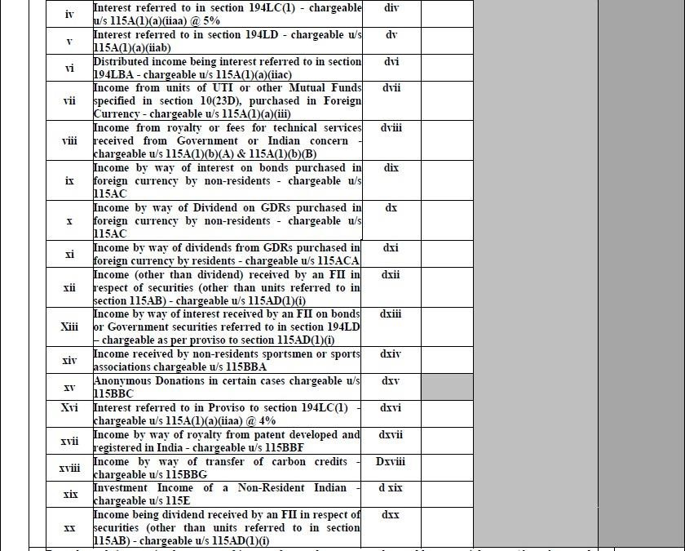

Section 194 LC- If an Indian company or a business trust pays income by way of interest to non-resident (not being a company) or foreign company, has to deduct TDS under this section. 194LD - The Government of India has introduced a new Section 194LD in the Income Tax Act, 1961 to provide tax deduction at source (TDS) at a concessional rate for interest income earned by a non-resident from government securities or rupee-denominated bonds.194 LBA-Any person who makes payment of income [as per section 115UA] which is payable by a business trust to its unit holder is required to deduct tax at source. Such unit holder can be a resident, non-resident (but not a company).
Section 115A-Tax on dividends, royalty and technical service fees in the case of foreign companies
Section 115AC- Section 115AC of IT Act, provides for tax on income from bonds or Global Depository Receipts purchased in foreign currency or capital gains arising from their transfer.

Section 10(23D)- Section 10(23D) of the Income Tax Act provides that any income earned by a Mutual Fund registered under the SEBI Act, 1992 or the Regulations made there under, shall not be included in computing its total income of a previous year.
Section 115AD- Section 115AD of income tax act provides tax on the income of Foreign Institutional Investors from securities or capital gains that arise from their transfer.
Section 115BBF-Section 115BBF provides concessional rate of taxation at 10% on royalty income in respect of exploitation of patents
Section 115UA-Notwithstanding anything contained in any other provisions of this Act, any income distributed by a business trust to its unit holders shall be deemed to be of the same nature and in the same proportion in the hands of the unit holder as it had been received by, or accrued to, the business trust.
Section 115UB-Notwithstanding anything contained in any other provisions of this Act and subject to the provisions of this Chapter, any income accruing or arising to, or received by, a person, being a unit holder of an investment fund, out of investments made in the investment fund, shall be chargeable to income-tax in the same manner as if it were the income accruing or arising to, or received by, such person had the investments made by the investment fund been made directly by him.
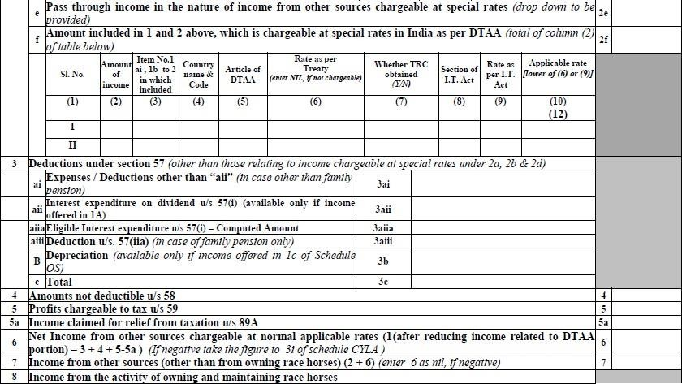

Section 57-
Any reasonable sum paid by way of commission or remuneration to a banker, or any other person for the purpose of realizing the interest.
(b)Interest on loan [Section57 (iii)]: Interest on money borrowed for investment in securities can be claimed as a deduction.

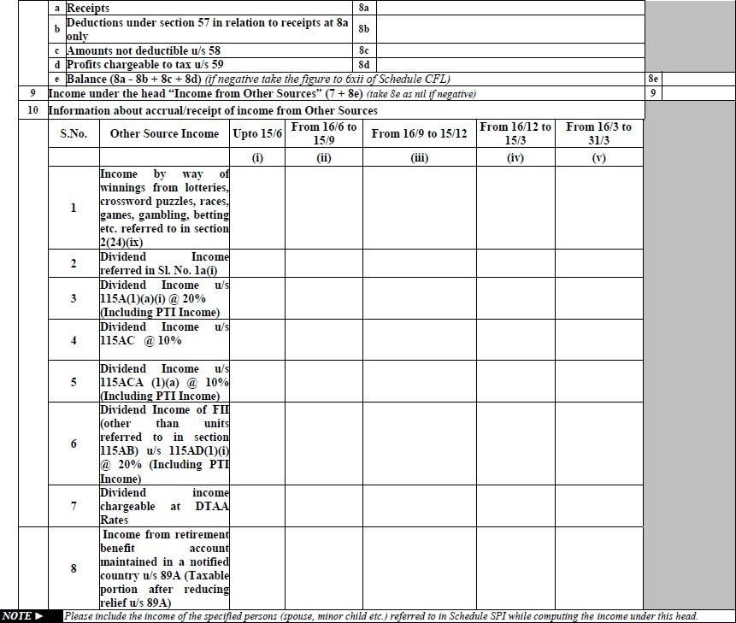

Expenses Not Deductible under section 58 are
- 58(1)(a)(i)-Personal expenses
- 58(1)(a)(ii)Interest chargeable to tax which is payable outside India on which tax has not been paid or deducted at source.
- 58(1)(a)(iii)-‗ Salaries payable outside India on which no tax is paid or deducted at source.
- 58(1A)- Wealth Tax.
- 58(2)- Expenditure of the nature specified in section 40A.
- 58(4)-Expenditure in connection with winnings from lotteries, crossword puzzles, races, games, gambling or betting.

Section 115ACA-provides for tax on income from Global Depository Receipts purchased in foreign currency or capital gains arising from their transfer.

DETAILS OF INCOME AFTER SETOFF OF CURRENT YEAR LOSS
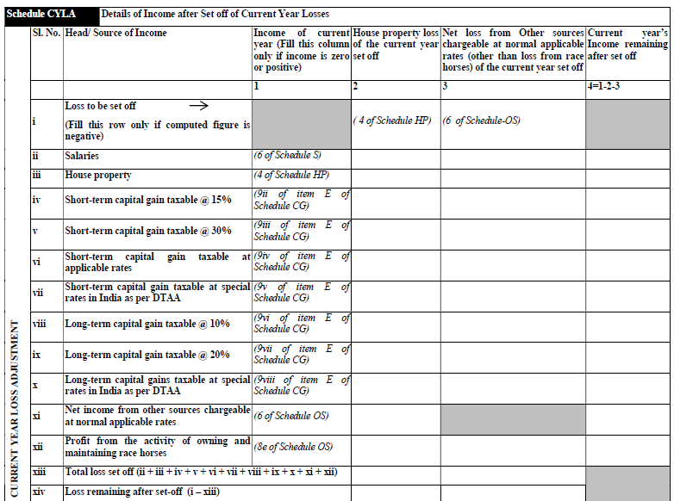

DETAILS OF INCOME SET OFF OF BROUGHT FORWARD LOSSES OF EARLIER YEARS
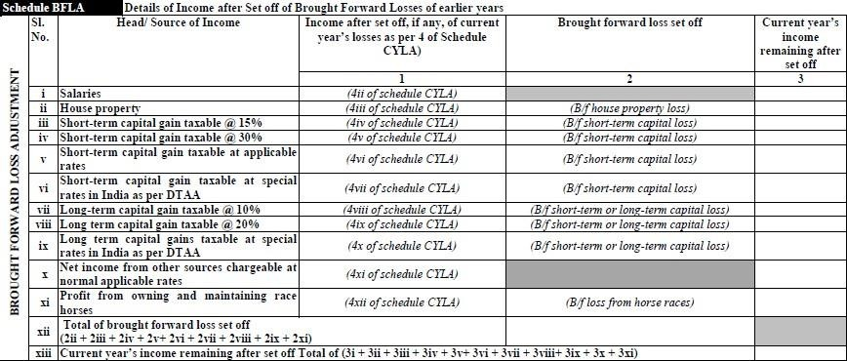

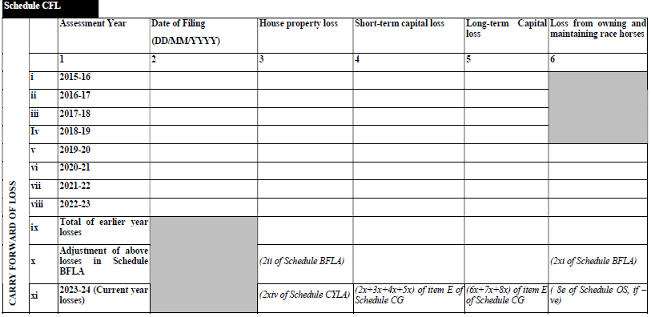
DETAILS OF LOSSESS TO BE CARRIED FORAWRD TO FUTURE YEARS
DEDUCTIONS UNDER CHAPTERVI-A

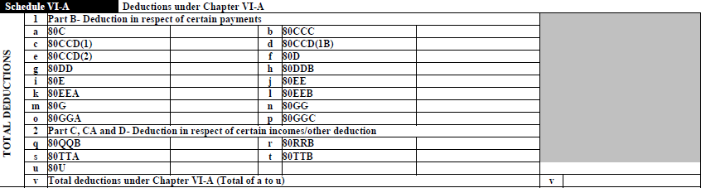

80C- Is one of the most popular and a favorite section amongst the taxpayers as it allows to reduce taxable income by making tax saving investments or incurring eligible expenses. It allows a maximum deduction of Rs 1.5 lakh every year from the tax payers total income.
The benefit of this deduction can be availed by Individuals and HUFs. Companies, partnership firms, LLPs cannot avail the benefit of this deduction.
SECTION 80 CCC- DEDUCTION FOR LIFE INSURANCE ANNUITY PLAN.
80CCC allows deduction for payment towards annuity pension plans Pension received from the annuity or amount received upon surrender of the annuity, including interest or bonus accrued on the annuity, is taxable in the year of receipt.

80 CCD (1)– DEDUCTION FOR NATIONAL PENSION SCHEME (NPS);
Employee‘s contribution under section 80 CCD (1) Maximum deduction allowed is least of the following
- 10%ofsalary(incase tax payer is employee)
- 20% of gross total income (in case of self-employed)
- Rs1.5 Lakh (limit allowed u/s80C).

80CCD (1b)-DEDUCTION FOR NPS;
Additional deduction of Rs 50,000 is allowed for amount deposited to NPS account. Contributions to Atal PensionYojana is also eligible for deduction.

80CCD(2)-DEDUCTION FOR NPS;
Employers contribution is allowed for deduction up to 10% of basic salary plusdearness allowance under this section. Benefit in this section is allowed only tosalariedindividualsandnotself-employed.

80D-DEDUCTIONFORTHEPREMIUMPAIDFORMEDICALINSURANCE;
An Individual/HUF can claim a deduction of Rs.25,000 under section 80D on insurance for self ,spouse and dependent children. An additional deduction for insurance of parents is available upto Rs25,000, if they are less than 60 years of age. If the parents are aged above 60, the deduction amount is Rs50,000
Incase, both taxpayer and parent(s) are 60 years or above, the maximum deduction available under this section is upto Rs.1 lakh.

80DD-DEDUCTIONFORREHABILITATIONOFHANDICAPPEDDEPENDENTRELATIVE;
Section 80DD deduction is available to a resident individual or a HUF and is available on:
- Expenditure incurred on medical treatment (including nursing), training and rehabilitation of handicapped dependent relative.
- Payment or deposit to specified scheme for maintenance of handicapped dependent relative.
  - Where disability is 40% or more but less than 80%– fixed deduction of Rs75,000.
  - Where there is severe disability (disability is 80% or more)–fixed deduction of Rs1,25,000.

80DDB-DEDUCTION FOR MEDICAL EXPENDITURE ON SELF OR DEPENDENT RELATIVE;
For Resident Individuals/HUF whose age is below 60 is allowed and eduction for medical Expenditure upto Rs.40,000.
In case the individual on behalf of whom such expenses are incurred is a senior citizen, the individual or HUF taxpayer can claim a deduction up to Rs1 lakh.

80E-DEDUCTION FOR INTEREST ON EDUCATION LOAN FOR HIGHER STUDIES;
A deduction is allowed to an individual for interest on loans taken for pursuing higher education. This loan may have been taken for the taxpayer, spouse or children or for a student for whom the tax payer is a legal guardian.
80E deduction is available for a maximum of 8 years (beginning the year in which the interest starts getting repaid)or till the entire interest is repaid, whichever is earlier.
There is no restriction on the amount that can be claimed.

80EE- DEDUCTIONS ON HOME LOAN INTEREST FOR FIRST TIME HOME OWNERS;
The deduction under section 80EE is available only to home-owners (individuals) having only one house property on the date of sanction of the loan.
Conditions to be satisfied for the availment of above deduction are:
- The value of the property must be less than Rs50 lakh
- The home loan must be less than Rs35 lakh.
- The loan taken from a financial institution must have been sanctioned between 1 April 2016 and 31 March 2017.

SECTION 80 EEA- DEDUCTION IN RESPECT OF INTEREST ON LOAN TAKEN FOR CERTAIN HOUSE PROPERTY.
- The total income of an assessee, being an individual not eligible to claim deduction under section 80EE, there shall be deducted, in accordance with and subject to the provisions of this section, interest payable on loan taken by him from any financial institution for the purpose of acquisition of a residential house property.
The deduction under sub-section(1) shall not exceed one lakh and fifty thousand rupees and shall be allowed in computing the total income of the individual for the assessment year beginning on the1st day of April,2020 and subsequent assessment years.

80G-DEDUCTION FOR DONATIONS TOWARDS SOCIAL CAUSES;
The various donations specified in u/s80G are eligible for deduction up to either 100% or 50% with or without restriction.
The Various Donation Under this section are as follows:
- Donations with 100% deduction without any qualifying limit
- Donations with 50% deduction without any qualifying limit
- Donations to the following are eligible for 100% deduction subject to 10% of adjusted gross total income
- Donations to the following are eligible for 50% deduction subject to 10% of adjusted gross total income
The donations above Rs2000 should be made in any mode other than cash to qualify for 80G deduction.

ARN (Donation Reference Number) is to be mentioned if the donation is eligible for Section 80G deduction.Any assessee who has paid any sum by way of donation is eligible to claim a deduction under Section 80G to the extent of 50% to 100% of the donation made. For certain donations, the deduction is allowed subject to the qualifying limit. In the new ITR forms, a new column has been inserted to disclose ARN (Donation Reference Number) in case the donation is made to entities wherein a 50% deduction is allowed subject to the qualifying limit

80GG–DEDUCTION IN RESPECT OF RENT PAID.
It has been introduced to provide relief to those individuals who do not receive any house rent allowance but are paying rent for the stay. Thus, an individual can claim a deduction for rent paid even if he or she does not get house rent allowance.

80GGA-DEDUCTIONINRESPECTOFDONATIONFORRESEARCH;
- In computing the total income of an assessee, there shall be deducted, in accordance with and subject to the provisions of this section, the sums specified in sub-section(2).
- The sums referred to in sub-section (1) shall be the following,namely:—
  - Any sum paid by the assessee in the previous year to a scientific research association which has as its object the undertaking of scientific research or to a University, college or other institution to be used for scientific research.
  - The sums referred to in sub-section(1)shall be the following, namely:—
    - to an association or institution, which has as its object the undertaking of any programmes of rural development, to be used for carrying out any programmes of rural development approved for the purposes of section 35CCA; or
    - to an association or institution which has as its object the training of persons for implementing programmes of rural development:
    - no deduction under this section shall be allowed in the case of an assessee whose gross total income includes income which is chargeable under the head "Profits and gains of business or profession".

  - Where a deduction under this section is claimed and allowed for any assessment year in respect to of any payments of the nature specified in sub-section (2), deduction shall not be allowed in respect of such payments under any other provision of this Act for the same or any other assessment year.'.

80GGC-DEDUCTION ON CONTRIBUTIONS GIVEN BY ANY PERSON TO POLITICAL PARTIES;
Deduction under section 80GGC is allowed to an individual taxpayer for any amount contributed to apolitical party or an electoral trust.
It is not available for companies,local authorities andan artificial juridical person wholly or partly funded by the government.
You can avail this deduction only if you pay by any way other than cash.

80QQB-DEDUCTIONFORROYALTYINCOME;
Section 80QQB is a facility introduced in the Income Tax Act for providinga tax -incentive to Indian authors. The section permits taxpayers to claim tax deductions on royalty earned from the sale of books. Only resident Indian authors are eligible to claim deduction under Section 80QQB.

80RRB-DEDUCTION WITH RESPECT TO ANY INCOME BY WAY OF ROYALTY OF APATENT;
Deduction for any income by way of royalty for a patent, registered on or after 1April2003 under the Patents Act 1970, shall be available for upto Rs.3lakh or the income received, whichever is less.The taxpayer must be an individual patentee and an Indian resident.Thetaxpayermustfurnishacertificateintheprescribedformdulysignedbytheprescribedauthority.

80TTA-DEDUCTION FROM GROSS TOTAL INCOME FOR INTEREST ON SAVINGS BANK ACCOUNT;
If you are an individual or an HUF,you may claim a deduction of maximum Rs10,000 against interest income from your savings account with a bank, co- operative society, or post office.Do include the interest from savings bank account in other income.
Section80TTA deduction is not available on interest income from fixed deposits, recurring deposits,or interest income from corporate bonds.

80TTB-DEDUCTION OF INTEREST ON DEPOSITS FORS ENIOR CITIZENS;
Deductions with respect to interest income from deposits held by senior citizens will be allowed. The limit for this deductionisRs.50,000.
No further deduction under section 80TTA shall be allowed.

80U-DEDUCTION FOR PERSON SUFFERING FROM PHYSICAL DISABILITY.
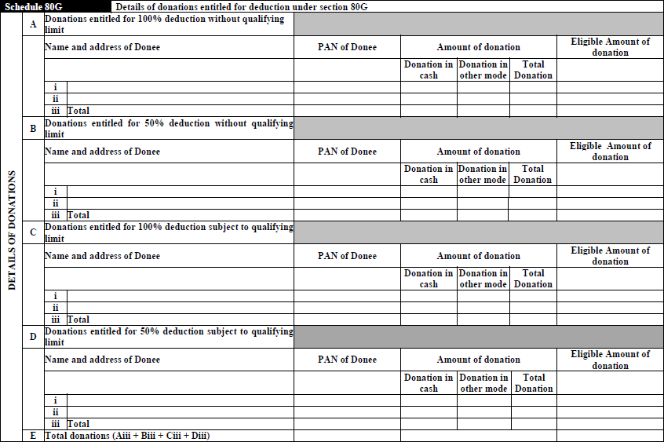
A deduction of Rs.75,000 is available to a resident individual who suffers from a physical disability (including blindness) or mental retardation .Incase of severe disability, one can claim a deduction of Rs1,25,000.
SCHEDULEOF80G

SCHEDULEOF80GGA

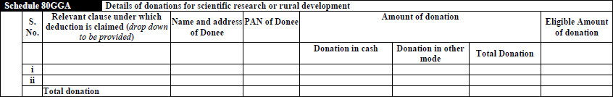

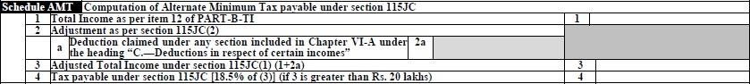
SCHEDULEOFALTERNATIVEMINIMUMTAX(AMT)

115JC–
Aspersection115JCoftheIncomeTaxAct,1961,anassesseeisliabletoAMTshouldobtainareportinFormNo-29CprescribedunderRule40BAfromCAcertifyingtheadjustedtotalincomeandthealternateminimumtaxdulycomputed andfurnishthereportonor before theduedate offilingthereturn u/s139(1).

SCHEDULEOFCOMPUTATIONOFTAXCREDITUNDERSECTION115JD

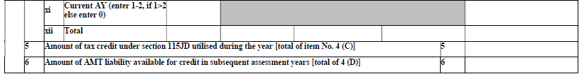
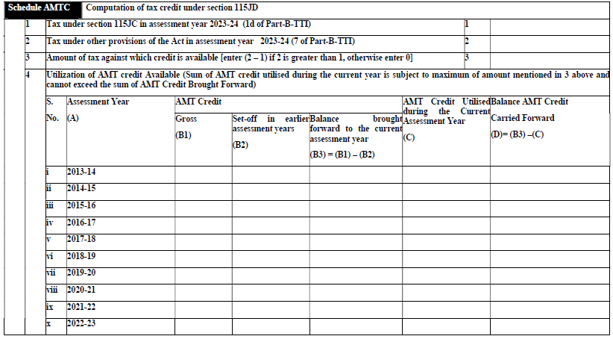

115JD-Section115JDprovidesthecreditfortax(taxcredit)paidbyanon-corporateonaccountofAMTshallbeallowedtothe extent ofthe excessofthe AMT paidover theregularIncome-tax.
NoInterestShallbepayableontaxcreditallowedundersection115JD.
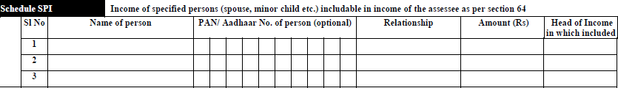
SCHEDULEOFINCOMEOFSPECIFIEDPERSONS
SCHEDULEOFINCOMECHARGEABLE TOTAXATSPECIALRATES

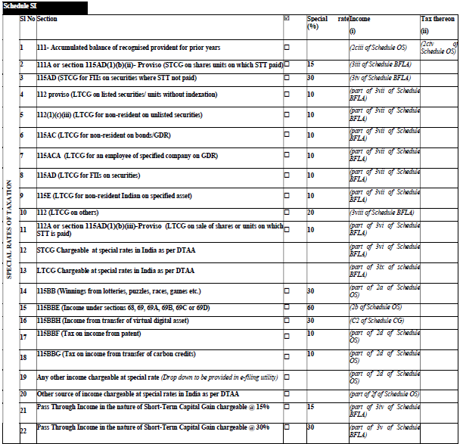

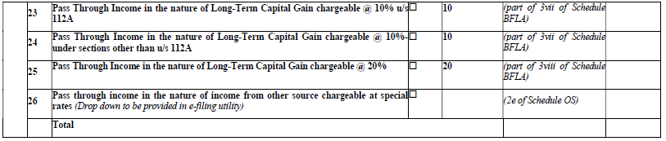

115E-Wherethetotalincomeofanassessee,beinganon-residentIndian,consistsonlyofinvestmentincomeorincomebywayoflong-termcapitalgainsorboth,thetaxpayablebyhimonhistotalincomeshallbetheamountofincome-taxcalculatedon suchtotalincomeattherateoftwentypercent ofsuch income.
115BBG-Taxonincomefromtransferofcarboncredits.—(1)Wherethetotalincomeofanassesseeincludesanyincomebywayoftransferofcarboncredits,theincome-taxpayableshallbetheaggregateof
- Theamountofincome-taxcalculatedontheincomebywayoftransferofcarboncredits,attherateoftenper cent;and
- Theamountofincome-taxwithwhichtheassesseewouldhavebeenchargeablehadhistotalincomebeenreducedbytheamountofincomereferredtoinclause(a).
115BBF-Wherethetotalincomeofaneligibleassesseeincludes anyincomebywayofroyaltyinrespectofapatentdevelopedandregisteredinIndia,theincome-taxpayableshallbetheaggregateof—
- Theamountofincome-taxcalculatedontheincomebywayofroyaltyinrespectofthepatentattherateoftenper cent;and
- Theamountofincome-taxwithwhichtheassesseewouldhavebeenchargeablehadhistotalincomebeenreducedbytheincomereferredtoinclause(a).

SCHEDULEOFEXEMPTINCOME
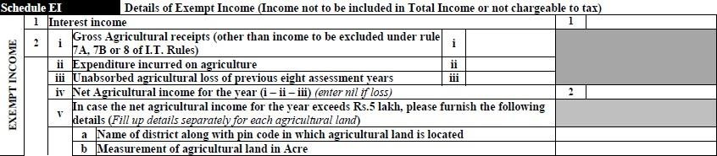
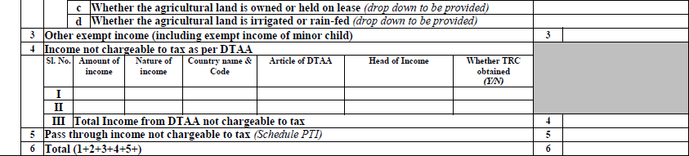

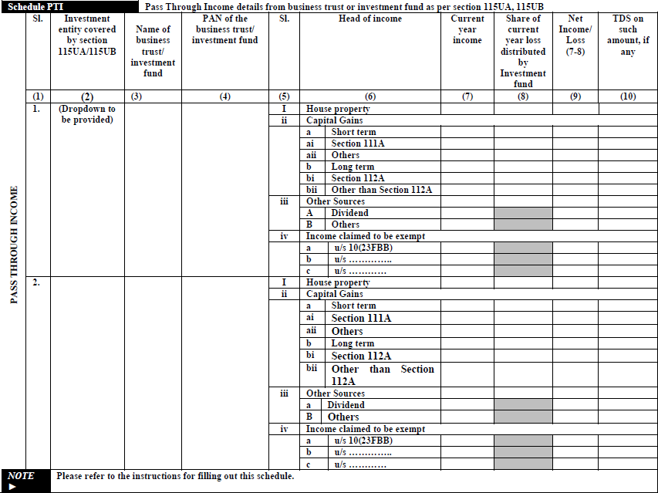
SCHEDULEOFPASSTHROUGHINCOME

10(23FBB)- Itmeans any income referred to in section115UB, accruingor arisingto, or receivedby, aunitholderof aninvestmentfund,beingthatproportionof incomewhichisofthesame
natureasincomechargeableunderthehead―Profitsandgainsofbusinessorprofession".
115UA-NotwithstandinganythingcontainedinanyotherprovisionsofthisAct,anyincomedistributed byabusinesstrust toitsunitholdersshallbedeemedtobeofthe samenature andinthesame proportion in the hands of the unit holder as it had been received by, or accrued to, thebusinesstrust.
115UB - Notwithstanding anything contained in any other provisions of this Act and subject to theprovisionsofthisChapter,anyincomeaccruingorarisingto,orreceivedby,aperson,beingaunitholderofaninvestmentfund,outofinvestmentsmadeintheinvestmentfund,shallbechargeabletoincome-tax in the same manner as if it were the income accruing or arising to, or received by, suchpersonhadthe investmentsmadebytheinvestmentfundbeenmadedirectlybyhim

SCHEDULEOFFOREIGNSOURCEOFINCOME

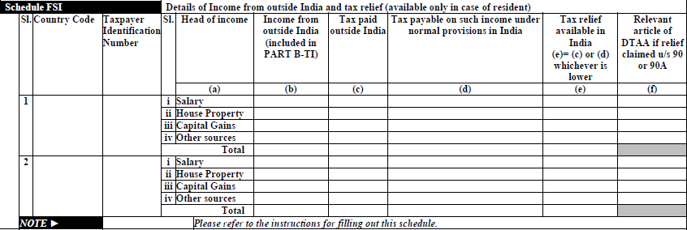

SCHEDULEOFTAXRELEFCLAIMEDFORTAXESPAIDOUTSIDEINDIA

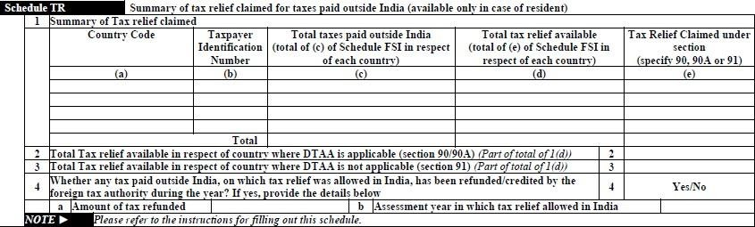

Section91 -Section 91 of Income Tax Act1961 provides forUnilateral Reliefwhich states thatwhenthereisnoDTAAbetweentwocountries,thereliefshallbeprovidedbythecountryofresidence.
ReliefunderthissectionmaybeclaimedbyanIndianresidentonlyifthereisnoDTAAwiththeothercountryfromwhereyouhaveearnedincome.SuchreliefisgivenvoluntarilybyIndiaincaseofunilateral agreements.

Section90 - TheCentralGovernmentmayenter into anagreementwiththeGovernmentofanycountryoutsideIndiaorspecifiedterritoryoutsideIndia,—
- forthegrantingofreliefinrespectof—
- incomeonwhichhavebeenpaidbothincome-taxunderthisActandincome-tax inthatcountryorspecifiedterritory,asthecasemaybe,or
- income-taxchargeableunderthisActandunderthecorrespondinglawinforceinthatcountryorspecified territory, as the case may be, to promote mutual economic relations, trade andinvestment,or
- fortheavoidanceofdoubletaxationofincomeunderthisActandunderthecorrespondinglawinforceinthatcountryorspecifiedterritory,asthecasemaybe,or
- for exchange of information for the prevention of evasion or avoidance of income-taxchargeableunderthisActorunderthecorrespondinglawinforceinthatcountryorspecifiedterritory,asthecasemaybe,orinvestigationofcasesofsuchevasionoravoidance,or
- forrecoveryofincome-taxunderthisActandunderthecorrespondinglawinforceinthatcountryorspecifiedterritory,asthecasemaybe,
Section90A-AnyspecifiedassociationinIndiamayenterintoanagreementwithanyspecifiedassociationinthespecifiedterritoryoutsideIndiaandtheCentralGovernmentmay,bynotificationintheOfficialGazette,makesuchprovisionsasmaybenecessaryforadoptingandimplementingsuchagreement—
forthegranting ofreliefinrespectof—
  - income on which have been paid both income-tax under this Act andincome-taxinanyspecifiedterritoryoutsideIndia;or
  - income-tax chargeable under this Act and under the corresponding law inforceinthatspecifiedterritoryoutside Indiatopromotemutualeconomicrelations,tradeandinvestment,or
- FortheavoidanceofdoubletaxationofincomeunderthisActandunderthecorrespondinglawinforceinthatspecifiedterritoryoutsideIndia,or
- Forexchangeofinformationforthepreventionofevasionoravoidanceofincome-taxchargeable under this Act or under the corresponding law in force in that specifiedterritoryoutsideIndia,orinvestigationofcasesofsuchevasionoravoidance,or
- Forrecoveryofincome-taxunderthisActandunderthecorrespondinglawinforceinthatspecifiedterritoryoutsideIndia.

SCHEDULE OF FOREIGN ASSETS AND INCOME FROM ANY SOURCE OUTSIDE INDIA

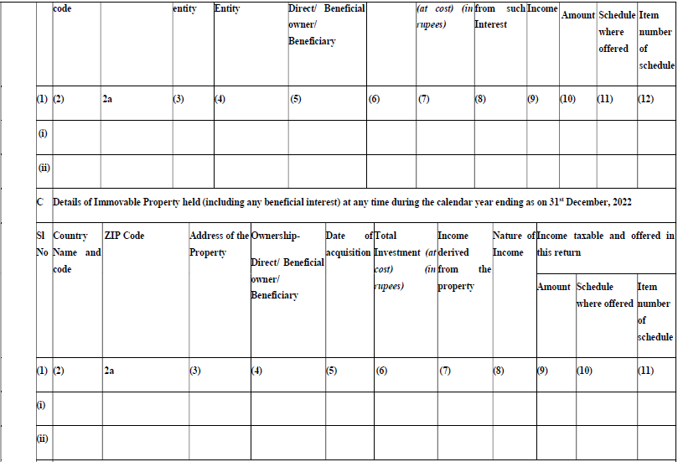
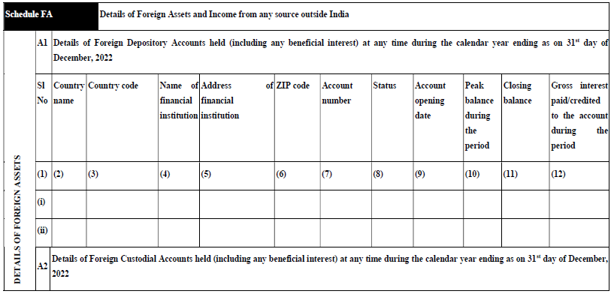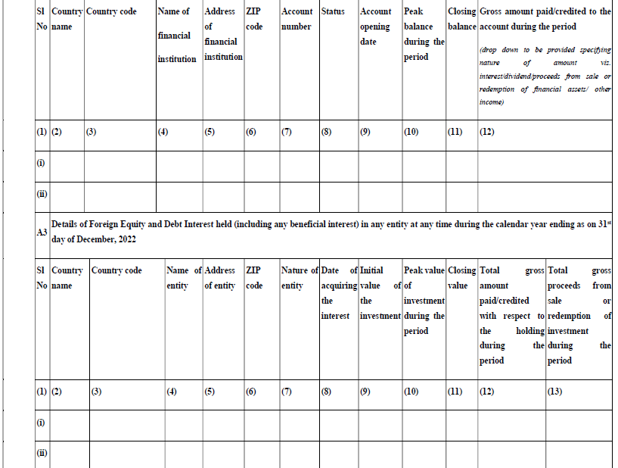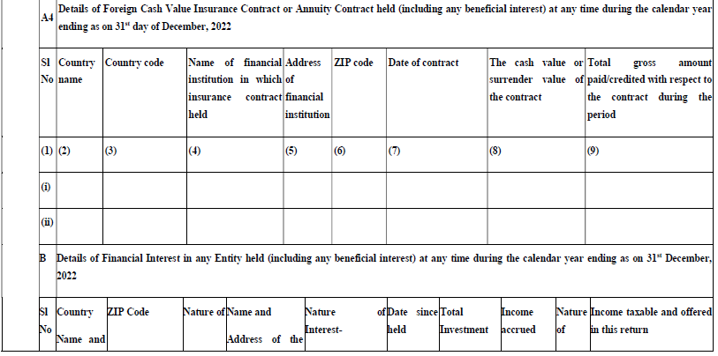
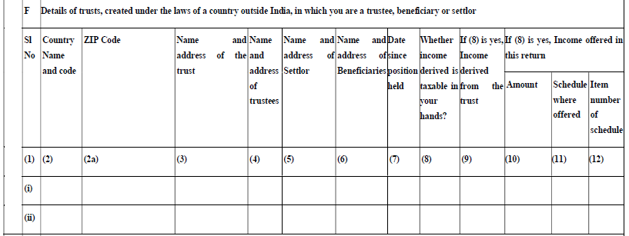
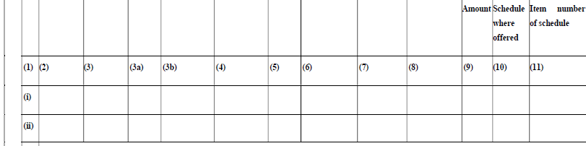
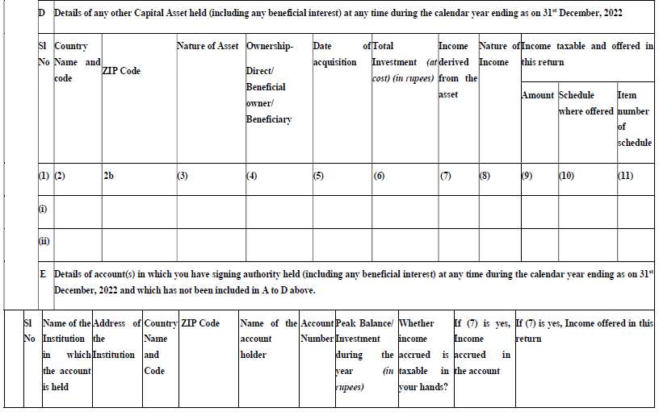
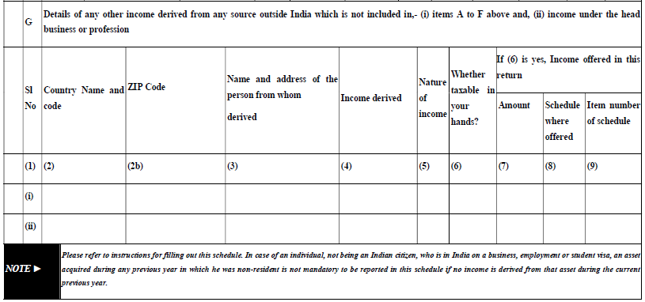

SCHEDULE5A–APPORTIONMENTOFINCOMEBETWEENSPOUSES

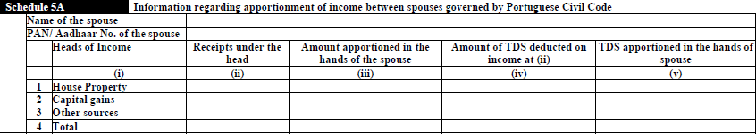

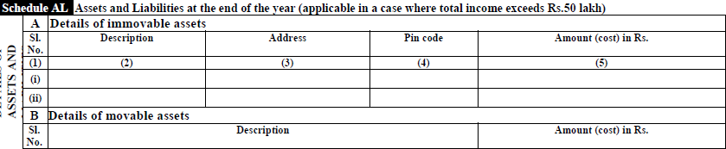
SCHEDULEOFASSESTANDLIABILITIESATHTHEENDOFTHE YEAR

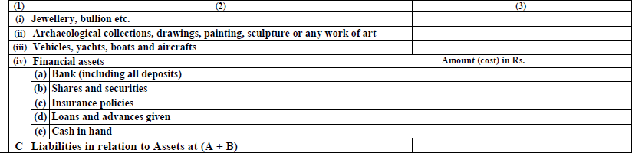
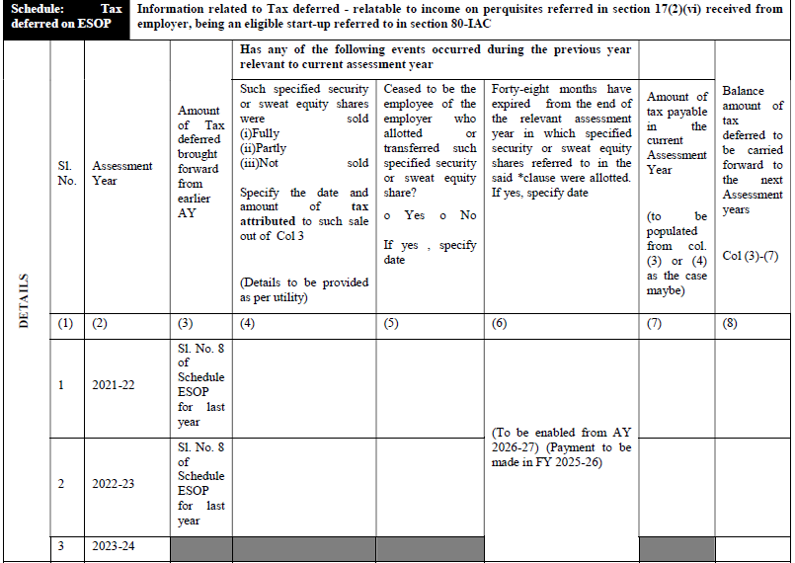
SCHEDULEOFTAXDEFERREDONEMPLOYEESTOCKOPTIONPLAN

17(2) -Section 17(2) of the Income Tax Act defines 'perquisite' as any benefit attached to an office orpositionalongwiththesalary/wages.Perquisitescanbeprovidedincashorkind.However,youmust notethatitistaxableunderthehead'Salaries'onlyiftheyare:
- Allowedbyanemployertohisemployee
- Allowedduringthecontinuanceoftheemployment
- Directlydependentupontheservice
- Resultingintopersonaladvantagetotheemployee
- Derivedasaresultoftheemployer'sauthority

80–IAC-Wherethegrosstotalincomeofanassessee,beinganeligiblestart-up,includesanyprofitsandgainsderivedfromeligiblebusiness,thereshall,inaccordancewithandsubjecttotheprovisionsofthissection,beallowed,incomputingthetotalincomeoftheassessee,adeductionofanamountequalto one hundred per cent of the profits and gains derived from such business forthree consecutiveassessmentyears.
- (2)Thedeductionspecifiedinsub-section(1)may,attheoptionoftheassessee,beclaimedbyhim for any three consecutive assessment years out of five years beginning from the year inwhichtheeligiblestart-upisincorporated.
- (3)Thissectionappliestoastart-upwhichfulfillsthefollowingconditions,namely:—
- itisnotformedbysplittingup,orthereconstruction,ofabusinessalreadyinexistence:

PARTB–TOTALINCOME

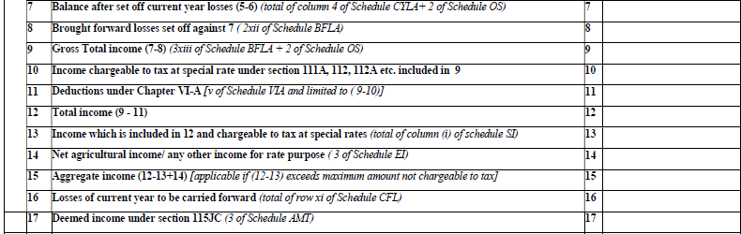
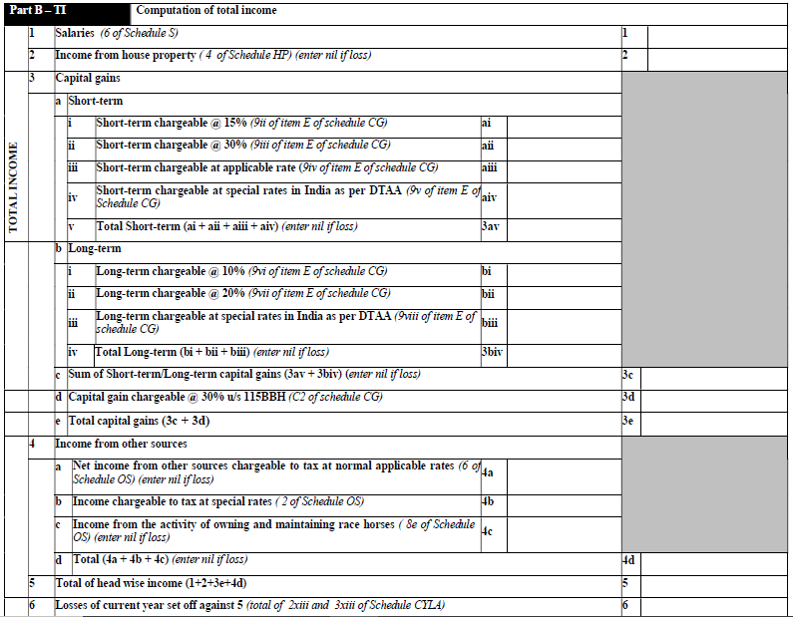

AGRICULTURALINCOME-The income which is derived from the agricultural activities are called as agricultural income.
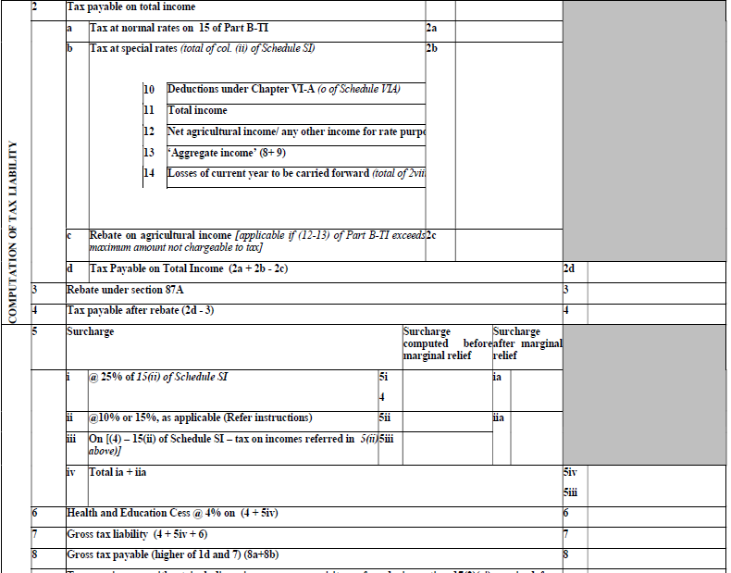
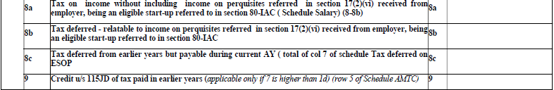
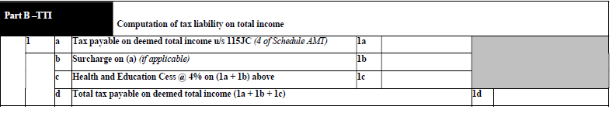

87A-AnyindividualwhoseannualnetincomeisnotmorethanRs.5LakhiseligibletoaclaimtaxrebateunderSection87AoftheIncomeTaxAct,1961.Thismeansanindividualcangetarebateonthetaxofup to Rs. 2,000. In this way, the deduction will be Rs. 2,000 or 100% of the salary of an individual,whicheverissmaller.

115JD-Asperthesection115JDoftheincometaxAct,theAlternateMinimumTax(AMT)ispayableincasethenormalamountoftaxpayableislessthanthetaxamountpayableunderAMT.AnydifferencebetweennormaltaxpayerandtaxpaidwithrespecttoAMTisallowedasan AMTcredit.

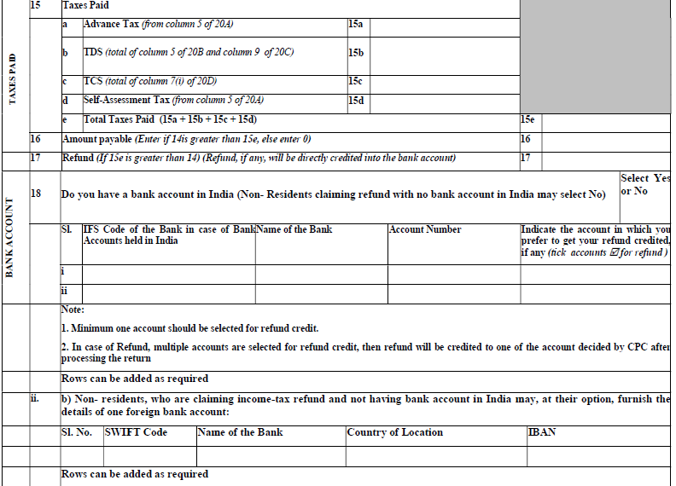
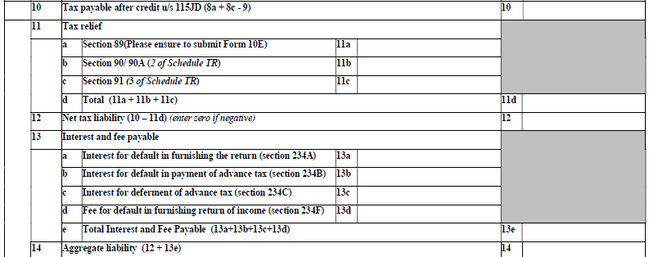
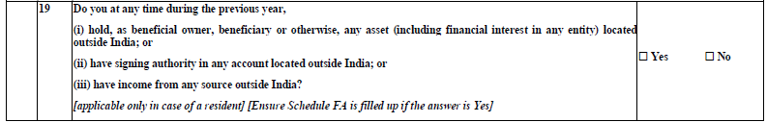

234A-Interestundersection234Aisleviedfordelayinfilingthereturnofincome.Interestisleviedat1% per month or part of a month. The nature of interest is simple interest. In other words, thetaxpayer is liable to pay simple interest @ 1% per month or part of a month for delay in filing thereturnofincome.
234B-Undersection234B,interestfordefaultinpaymentofadvancetaxisleviedat1%permonthorpart of a month. The nature of interest is simple interest. In other words, the taxpayer is liable to paysimpleinterestat1%permonthorpartofamonthfordefaultinpaymentofadvancetax.
234C-Section 234C:Paymentof Advance Tax not onTime orInterestforDeferment of Advance Tax.Section234CoftheIncomeTaxActdefinestherateofinterestandconditionsifyoudelaytheadvancetaxinstalments.Everyone,includingsalariedtaxpayers,isrequiredtopayadvancetaxeveryquarterofthefinancial year.
234F-Aspersection234FoftheIncome-taxAct,taxpayersmustpayapenaltyfordelayinfilingITR.Insimplewords,ifyoufailtofileyourtaxreturnswithinthedeadlineforthecurrentyeari.e.,31stofDecember,youmightenduppayinguptoINR5,000aspenalties.

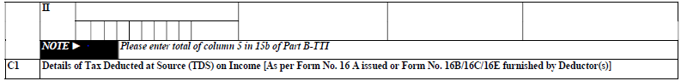
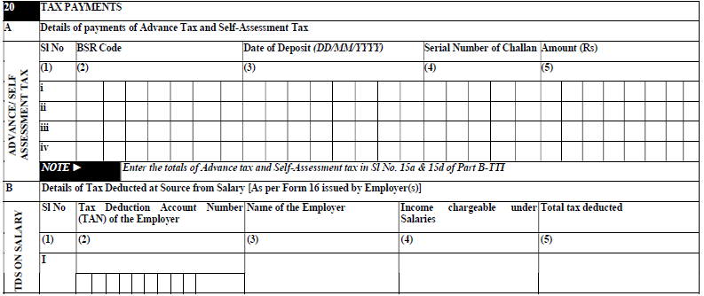

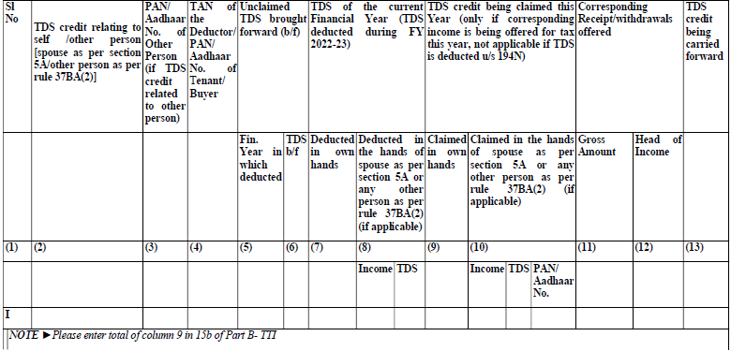
ADVANCE TAX -Advance tax is the amount of income tax that is paid much in advance rather than a lump-sum payment at the year-end. Also known as earn tax, advance tax is to be paid in installments as per the due dates decided by the income tax department.
SELF ASSESSMENT TAX-Self-Assessment tax means the tax obligation of a taxpayer after considering tax deducted at source and advance tax . Self-assessment tax is paid during the assessment year before the income tax returns are filed by submitting Challan 280.

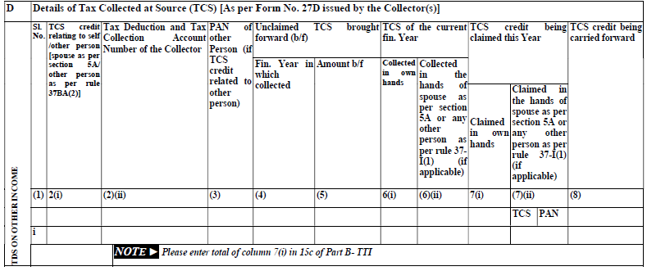

Transfer of TCS credit to another person

All citizens who are domiciled in Goa and to whom the Portuguese Civil Code of 1860 apply are governed by the system of Community of Property. Under this system, a person is entitled to inherit 50%of the property of his spouse, and the income therefrom is also liable to be shared equally among the spouse. Under Section 5A, the statute has recognised the system of community of property for the purpose of assessment in respect of all income other than salary.

In this situation, if an income added to the common pool has been subjected to TCS, the assessees face difficulties in proving their claim for TCS credit. In other similar situations, a person is entitled to claim the credit for tax deducted in the name of another person, i.e., inheritance, etc.

Currently, Income-tax Dept. matches the TCS disclosed in ITR with the amount of TCS as shown in Form 26AS and in case of a mismatch, the Dept. asks the assessee to reconcile the mismatch. Therefore, in the situations mentioned above, the taxpayers were facing difficulties in claiming the TCS credit. To overcome this problem, the ITR forms introduce new columns in the TCS Schedule, allowing CPC. to correlate the PAN, amount of income, and TCS thereon as disclosed by both parties in their respective return of income. It would be more convenient for the assessee to claim the credit of tax deducted in the name of another person.

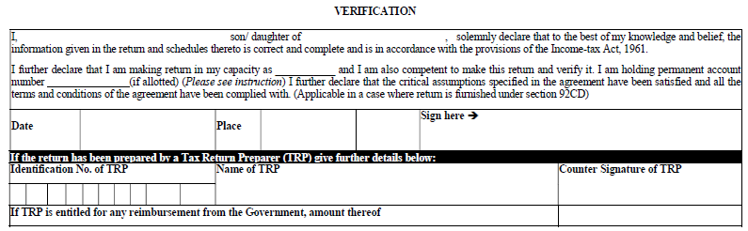

92CD-EFFECT TOADVANCEPRICING AGREEMENT;
Notwithstanding anything to thecontrarycontained in section139,where anypersonhasentered into an agreement and prior to the date of entering into the agreement, anyreturn of income has been furnished under the provisions of section 139 for anyassessmentyearrelevanttoapreviousyeartowhichsuchagreementapplies,suchpersonshallfurnish,withinaperiodofthreemonthsfromtheendofthemonthinwhichthesaid agreement was entered into, a modified return in accordance with and limited to theagreement.

HOW TO FILE FORM ITR-2
- Logintotheportalhttps://www.incometax.gov.in/iec/foportal,screenwill bedisplayas

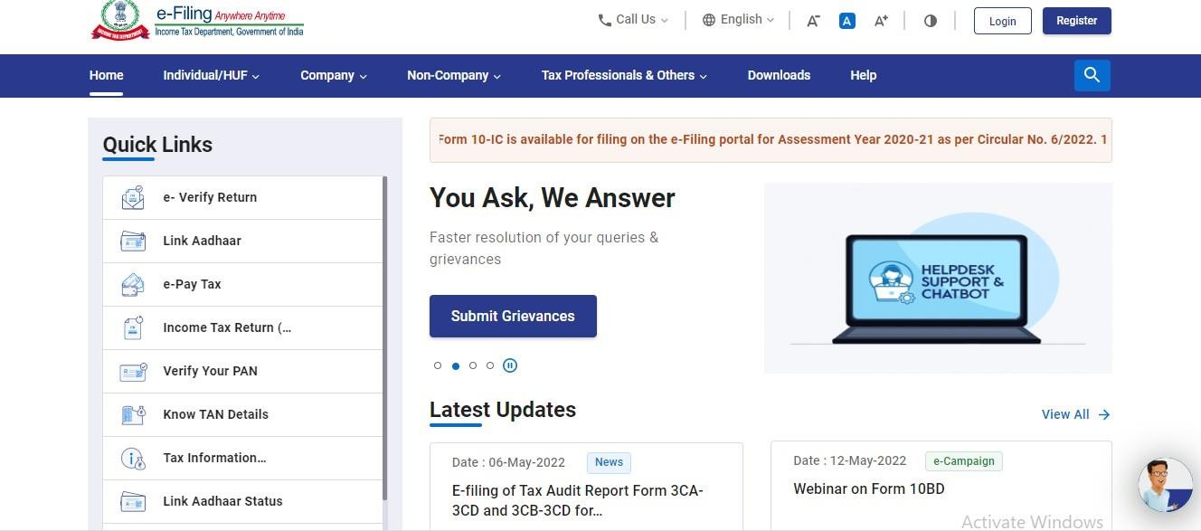

- clickontheLoginifyouarealreadyaregisteredperson,otherwiseclickontheregisterbuttonandregisterusingyourvalidcredentialsuchasPAN,Aadharetc..

After LoginWith the Credential such as PAN Number and the Income tax passwordThisWindowwillbedisplayed..
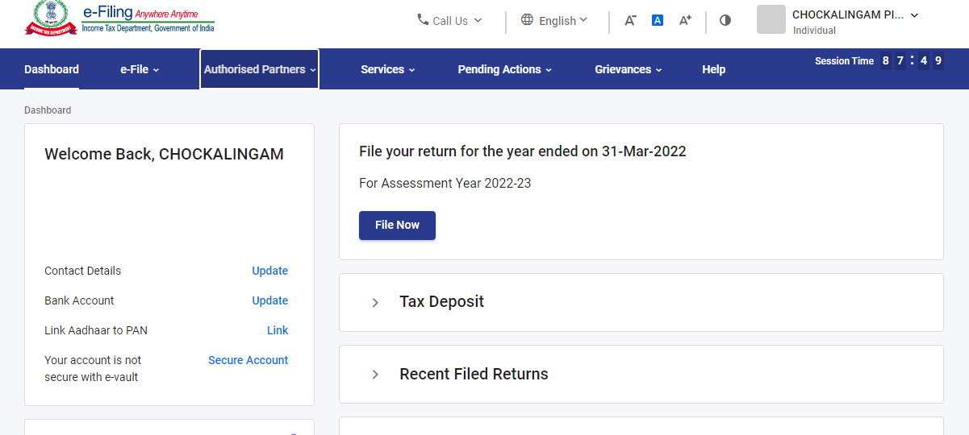
- ThengotoE-File,clickonthat,andthewindowdisplayedwillbeas;
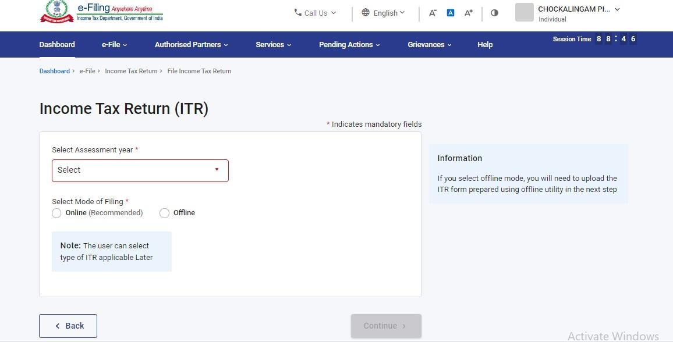

- ThenselecttheAssessmentYearfromtheDropdownlist
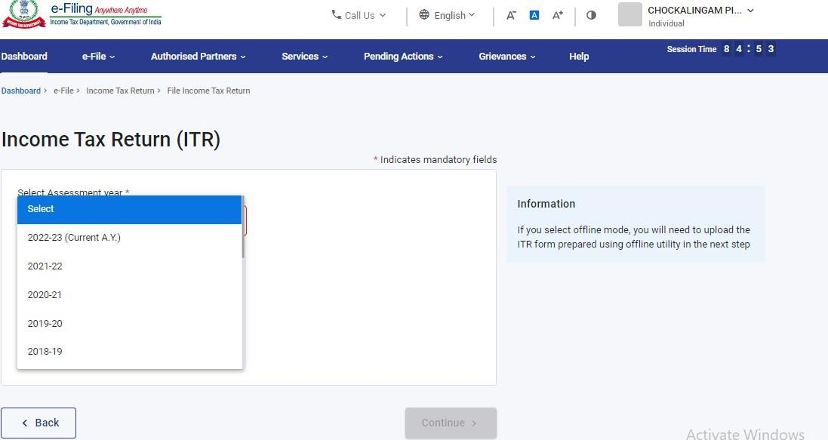

- selectthemodeoffiling

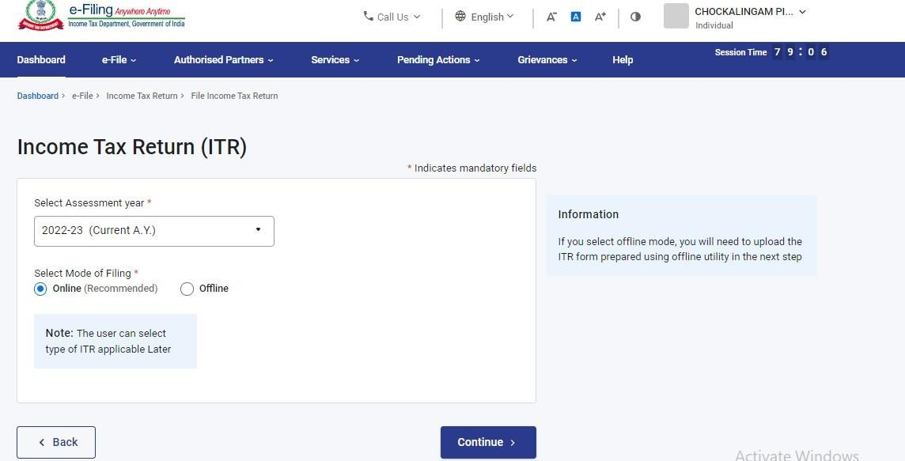

- clickonthestartnewfilingbutton

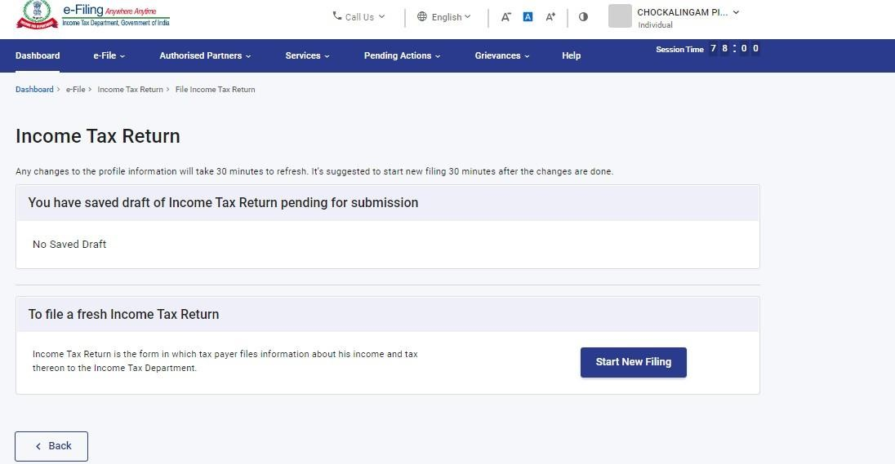
- SelecttheStatusapplicable

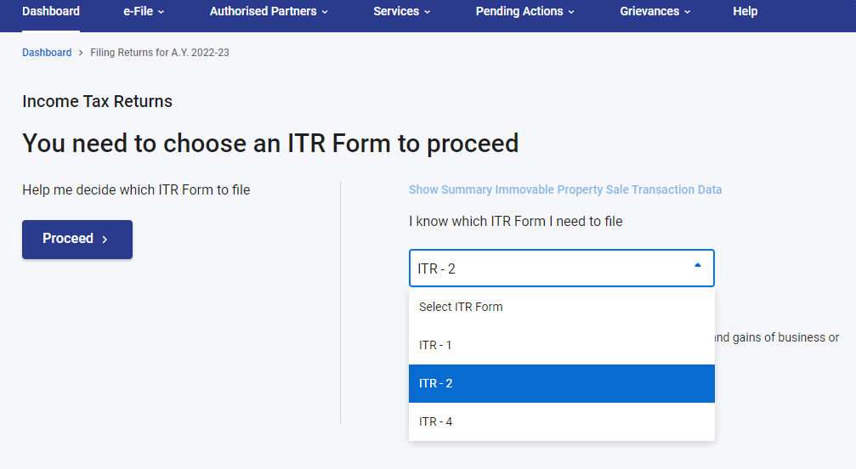

- ClickontheLetsGet StartedButton

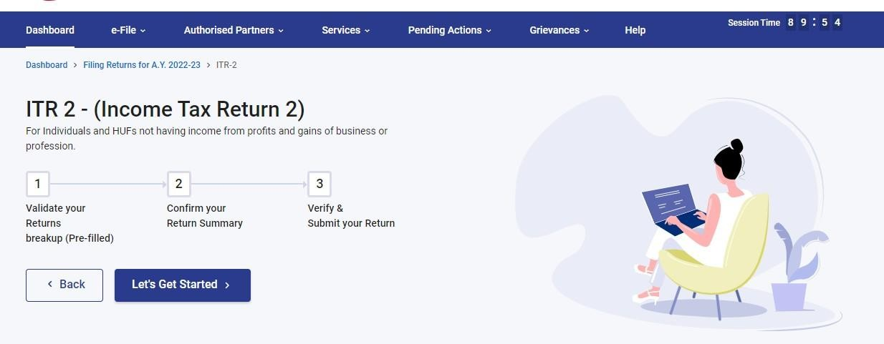
- SelecttheAppropriatereasonforwhichtheITRisfillingandclickthecontinue
button;
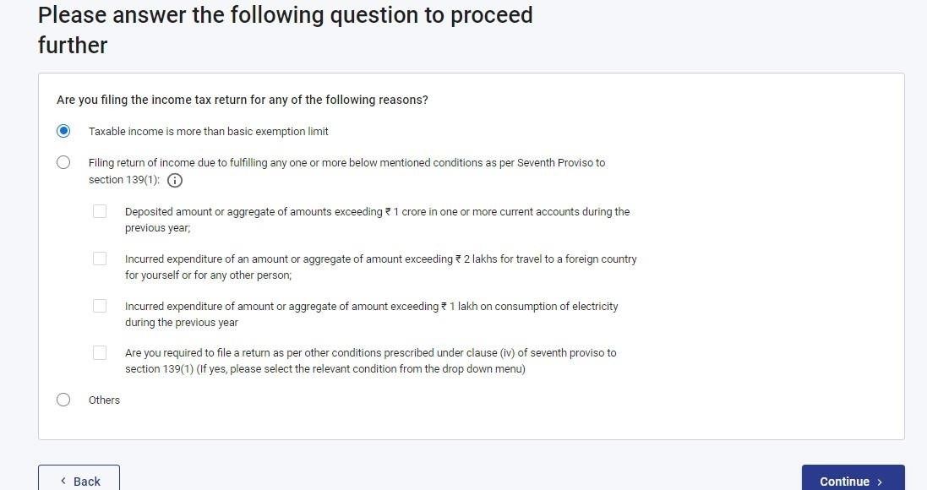

x)Selecttheappropriateschedules.

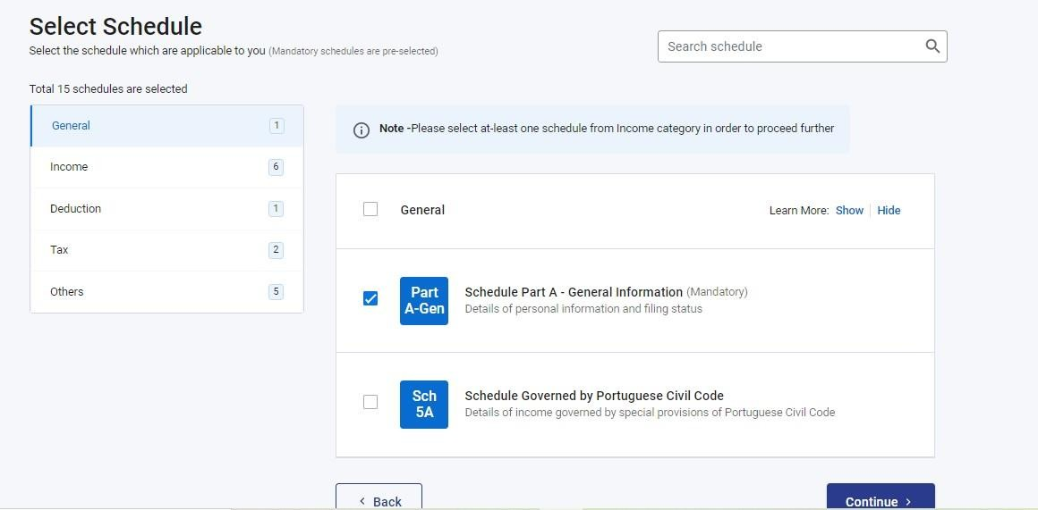

PartAisGeneralInformation(Mandatory).enterthebasicdetailsforfillingITR.
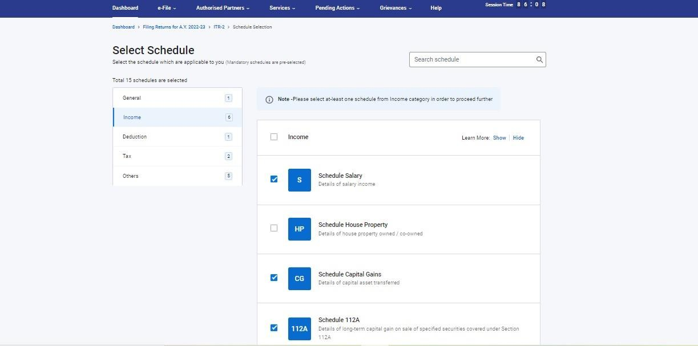

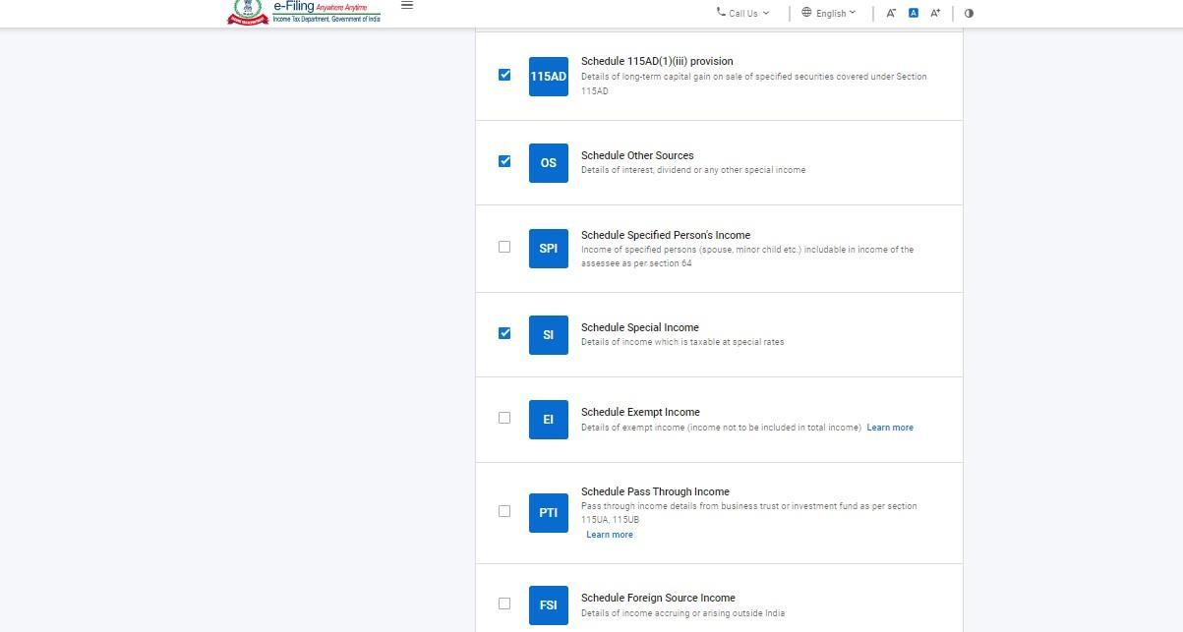


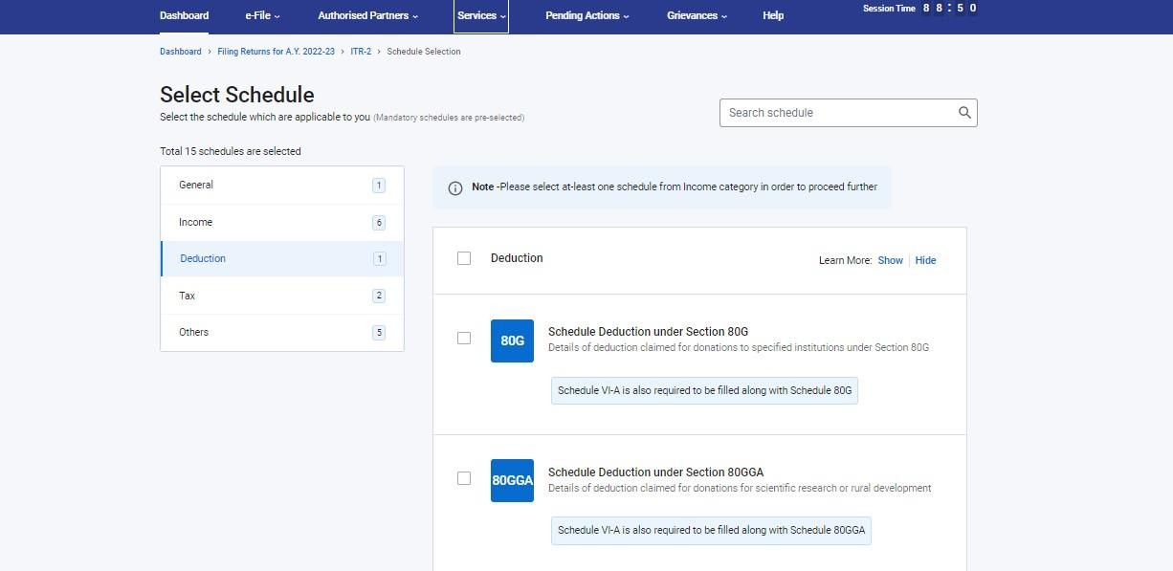

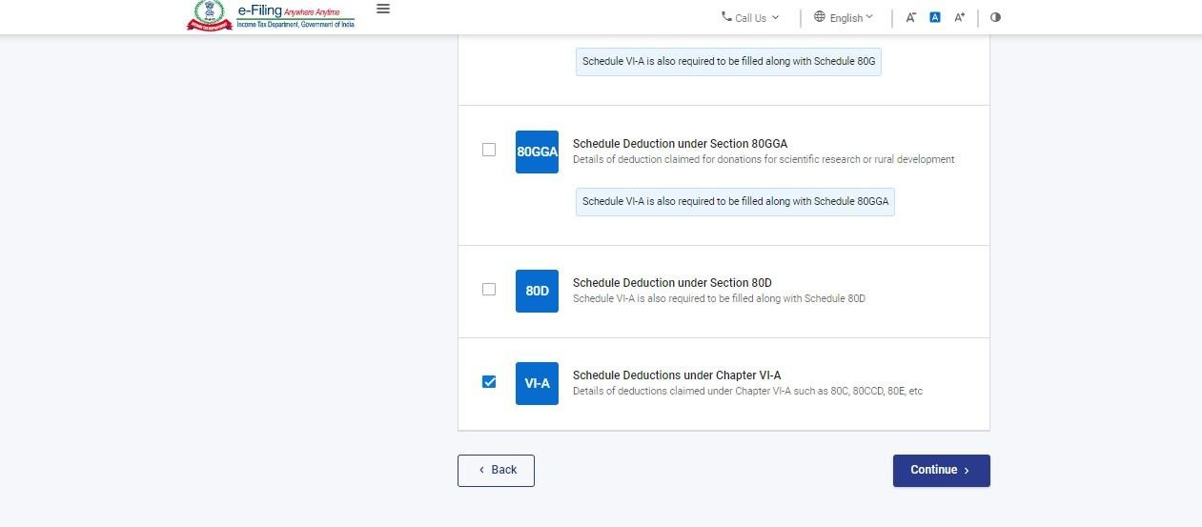

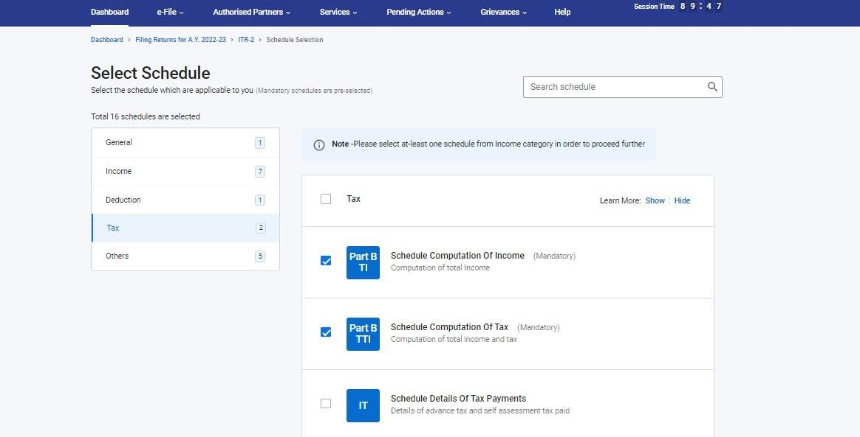

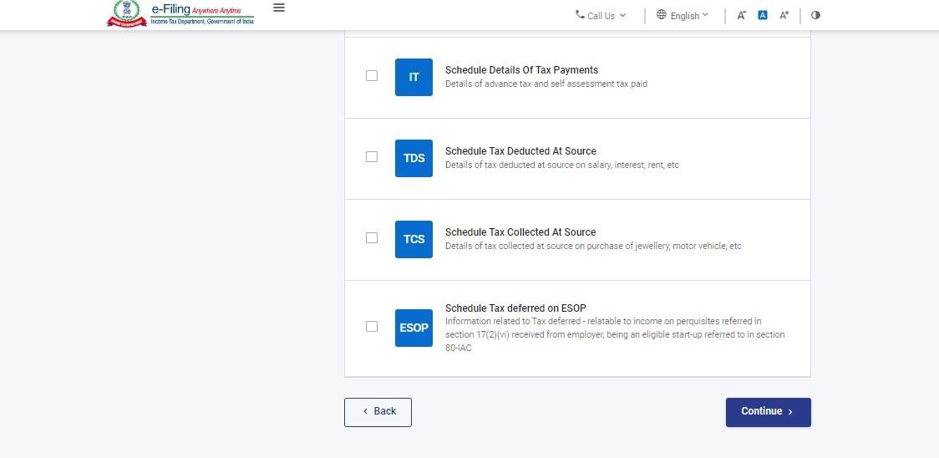

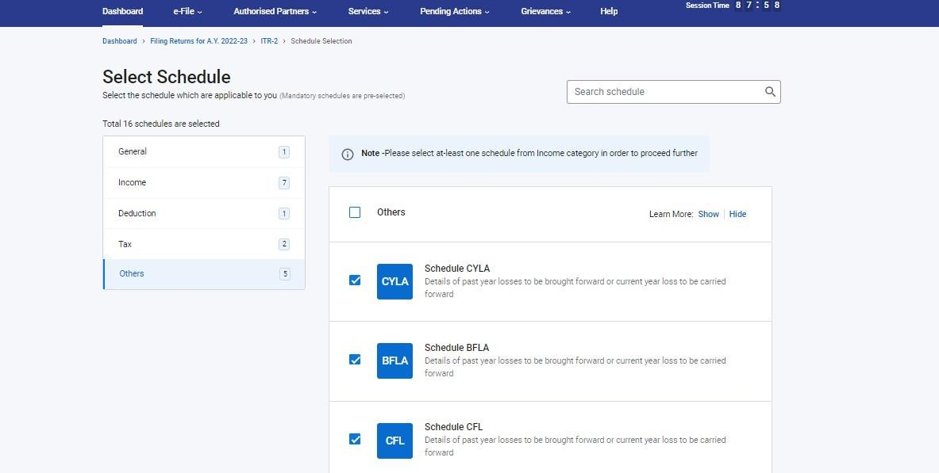

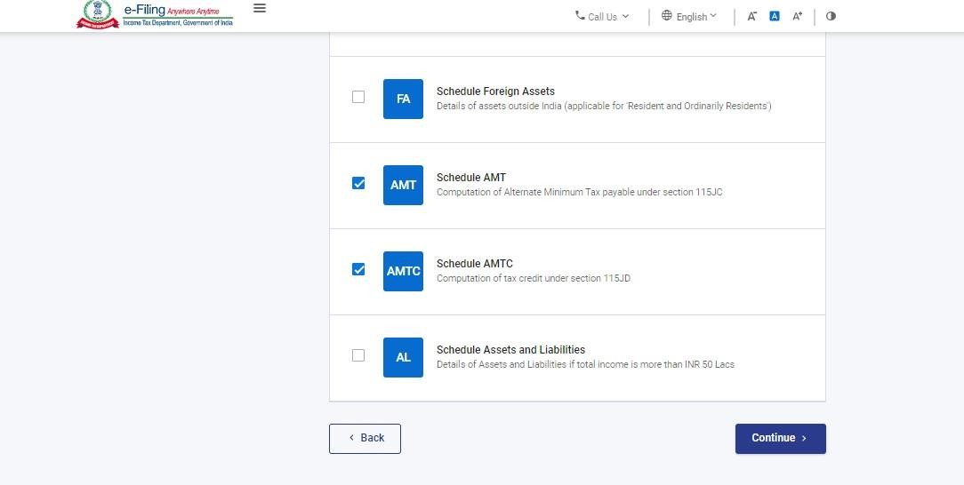

- Aftercompletingandconfirmingallsectionsoftheformclickproceed.
- Incase thereisaTaxliability;Youwill beshownasummary ofyour taxcomputationbasedonthedetailsprovidedbyyou.Ifthereistaxliabilitypayablebasedonthecomputation,yougetthePayNowandPayLateroptionsat thebottomofthepage.

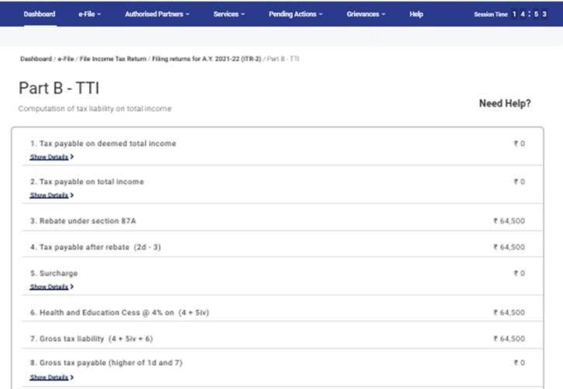

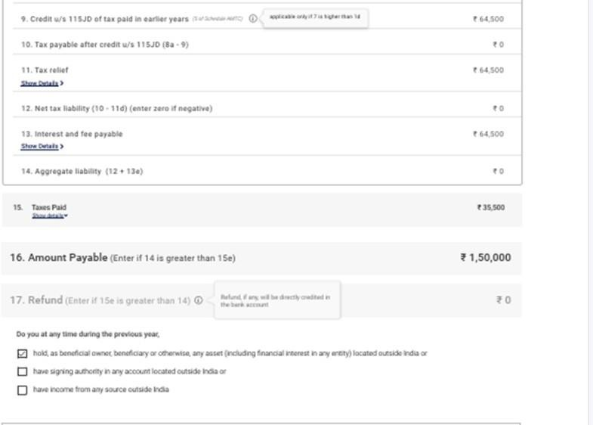


- ItisrecommendedtousethePayNowoption.CarefullynotetheBSRCodeandChallanSerialNumberandentertheminthedetailsofpayment.
If you opt to Pay Later, you can make the payment after filing your Income TaxReturn,butthereisariskofbeingconsideredasanassesseeindefault,andliabilitytopayinterestontaxpayablemayarise.
- Incasethereisnotaxliability(NoDemand/NoRefund)orifyouareeligibleforaRefund
Afterpayingtax, clickPreviewReturn.If thereisno tax liabilitypayable,or if thereisarefundbased on tax computation, youwill betaken to thePreview and SubmitYourReturnpage.

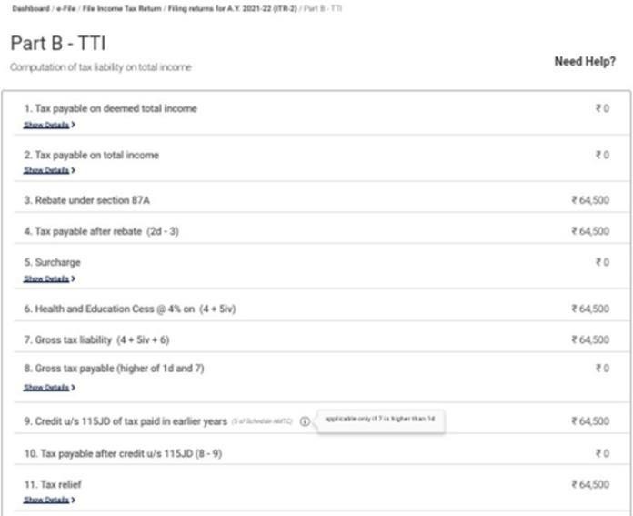

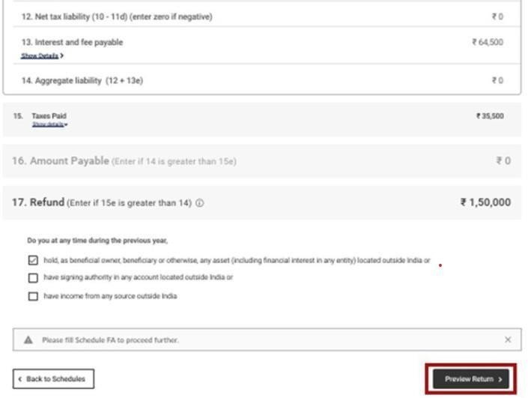

- OnthePreviewandSubmitYourReturnpage,enterPlace,selectthedeclarationcheckboxandclickProceedtoValidation
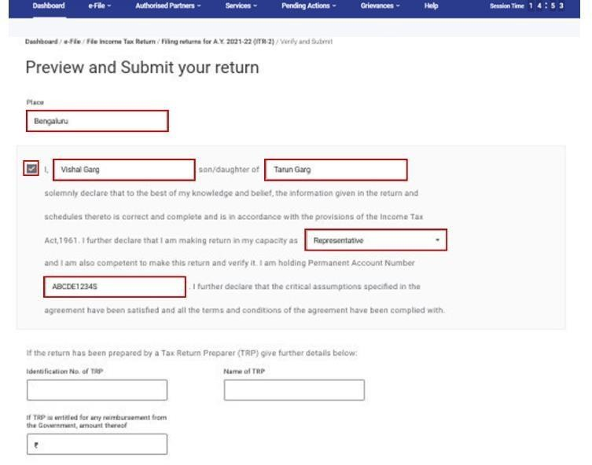


- Oncevalidated,onyourPreviewandSubmityourReturnpage,clickProceedtoVerification.
- OntheCompleteyourVerificationpage,selectyourpreferredoptionandclickContinue.
+

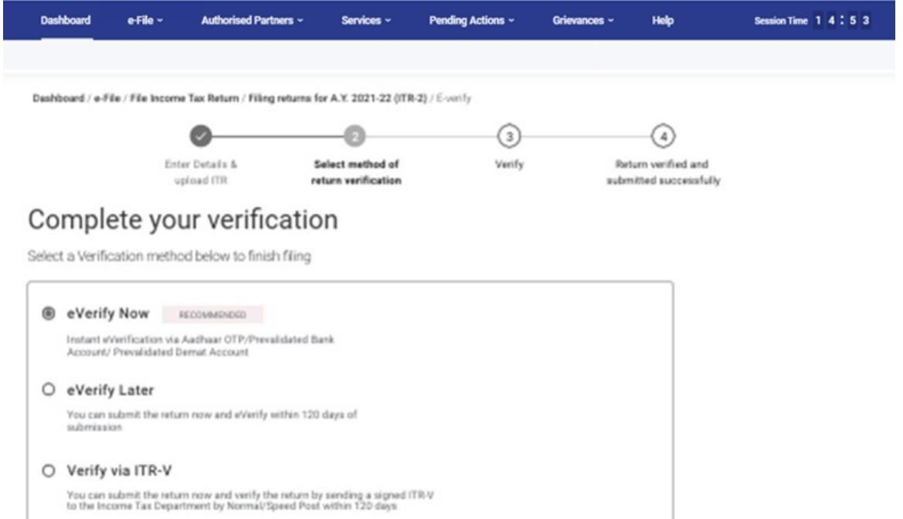


In caseyouselecte-VerifyLater,you cansubmit your return,however, youwillberequiredtoverifyyourreturnwithin120daysoffilingofyourITR.
- Onthee-Verifypage,selecttheoptionthroughwhichyouwanttoe-Verifythereturnandclick Continue.

Onceyoue-Verifyyourreturn,a successmessageisdisplayedalongwiththeTransactionIDandAcknowledgmentNumber.YouwillalsoreceiveaconfirmationmessageonyourmobilenumberandemailIDregisteredonthee-Filingportal.
