1. Overview

Form 35 is available for use to any assessee / deductor aggrieved by an order of the Assessing Officer (AO). In such a case, the appeal can be filed against the order of the AO before the Joint commissioner (Appeals) or Commissioner of Income Tax (Appeals) using Form 35.

e-filing of Form 35 has been made mandatory for persons for whom e-Filing of return of income is mandatory. For persons for whom e-Filing of Return of Income is not mandatory, Form 35 can be filed either in electronic form or paper form. An appeal is required to be filed along with Memorandum of Appeal, Statement of facts and the Grounds of appeal and should be accompanied by a copy of the order appealed against and the notice of demand.

2. Prerequisites for availing this service

• Registered user on the e-Filing portal with valid user ID and password  
• PAN and Aadhaar are linked (Recommended)  
• Valid Digital Signature Certificate (DSC) registered on the e-Filing portal, which is not expired, if the Return of Income is required to be verified using DSC. In any other case, EVC is required.

3. About the Form

3.1 Purpose  
  
If you are not satisfied with the order passed by your AO and aggrieved with respect to any additions, disallowances, reduction of benefits, exemptions, or benefit of losses, you may file an appeal with the Joint Commissioner (Appeals) or Commissioner of Income Tax (Appeals) using Form 35..  
  
3.2 Who can use it?

Any assessee/ deductor can use Form 35. Every appeal is accompanied by payment of an appeal fee which is required to be paid before filing of Form 35. The quantum of appeal fees is dependent on the total income as computed or assessed by the AO.

4. Form at a Glance

Form 35 has nine sections that you need to fill before submitting the form. These are:

* Basic Information
* Order against which Appeal is filed
* Pending Appeal
* Appeal Details
* Details of Taxes Paid
* Statement of facts, Grounds of Appeal and additional evidence
* Appeal filing details
* Attachments
* Form of Verification

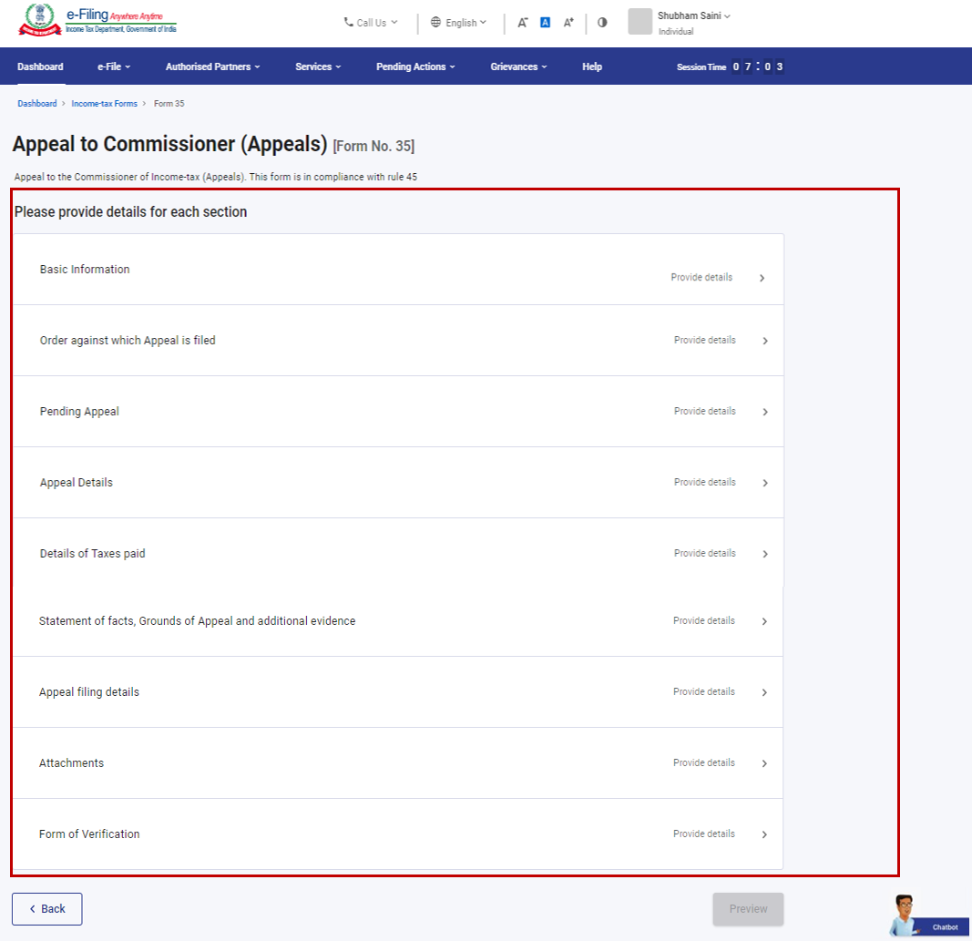

4.1 Basic Information  
  
The Basic Information page is where you can review your personal information, including PAN and contact details. Contact details are prefilled in the Form.

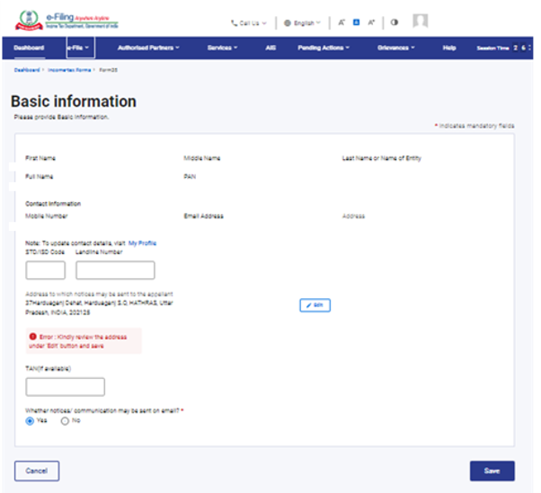

4.2 Order against which Appeal is filed  
  
In the Order against which Appeal is filed page, select the Assessment Year and provide the necessary order details.

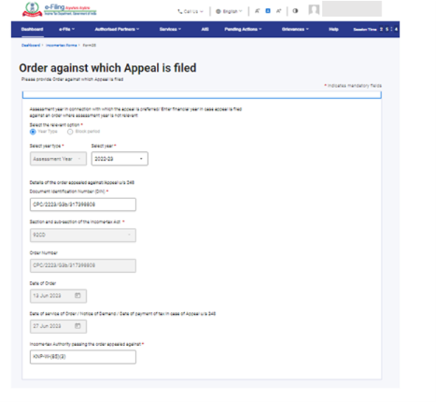

4.3 Pending Appeal

The Pending Appeal section provides details of your pending appeal, if any, from a previous Assessment Year (AY). You have the opportunity to review the information and edit as needed.

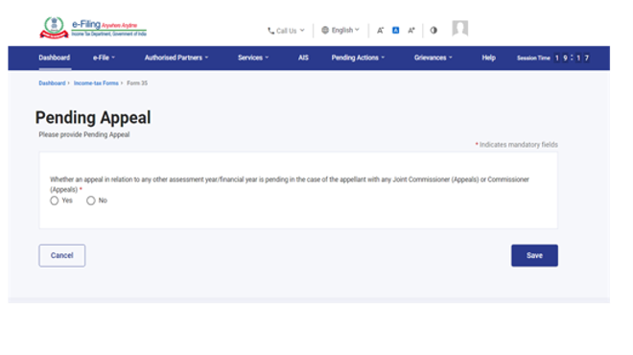

4.4 Appeal Details  
  
In the Appeal Details page, you can state if the appeal relates to assessment or penalty levied by the Income Tax Department.

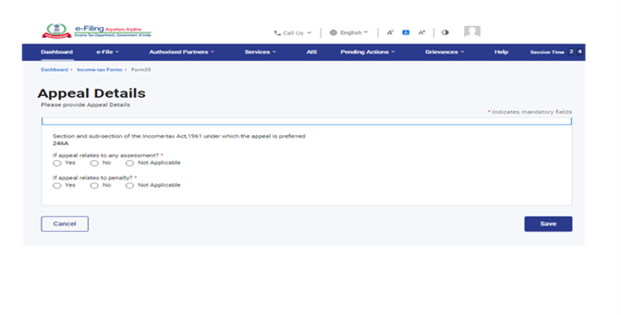

4.5 Details of Taxes Paid  
  
The Details of Taxes Paid page is where you provide details of taxes you have paid for the AY.

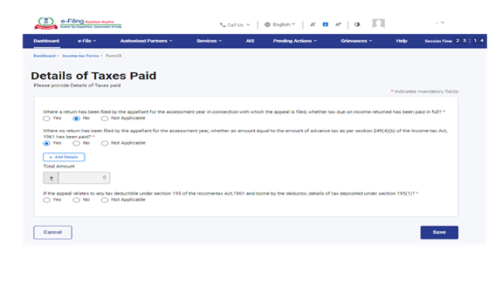

4.6 Statement of facts, Grounds of Appeal and additional evidence  
  
In the Statement of facts, Grounds of Appeal and additional evidence page, you can provide the facts of your case in a short paragraph and on what grounds you are filing an appeal.

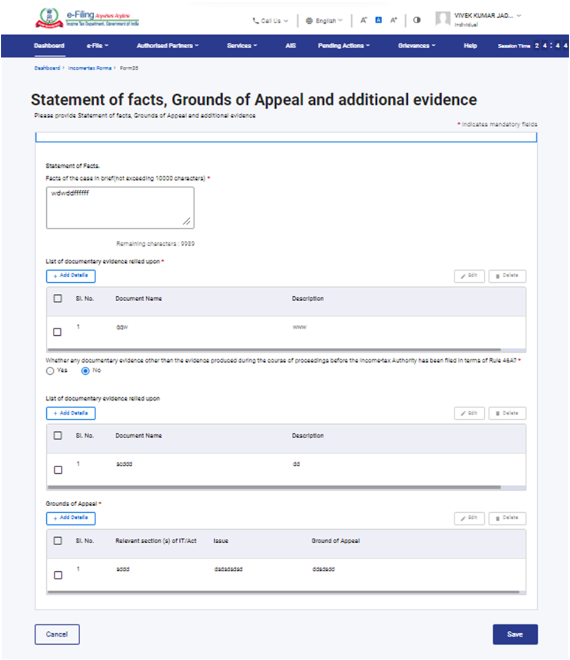

4.7 Appeal filing details

The details of grounds of condonation of delay (if there was a delay in filing of appeal) and appeal fees is provided on the Appeal filing details page.

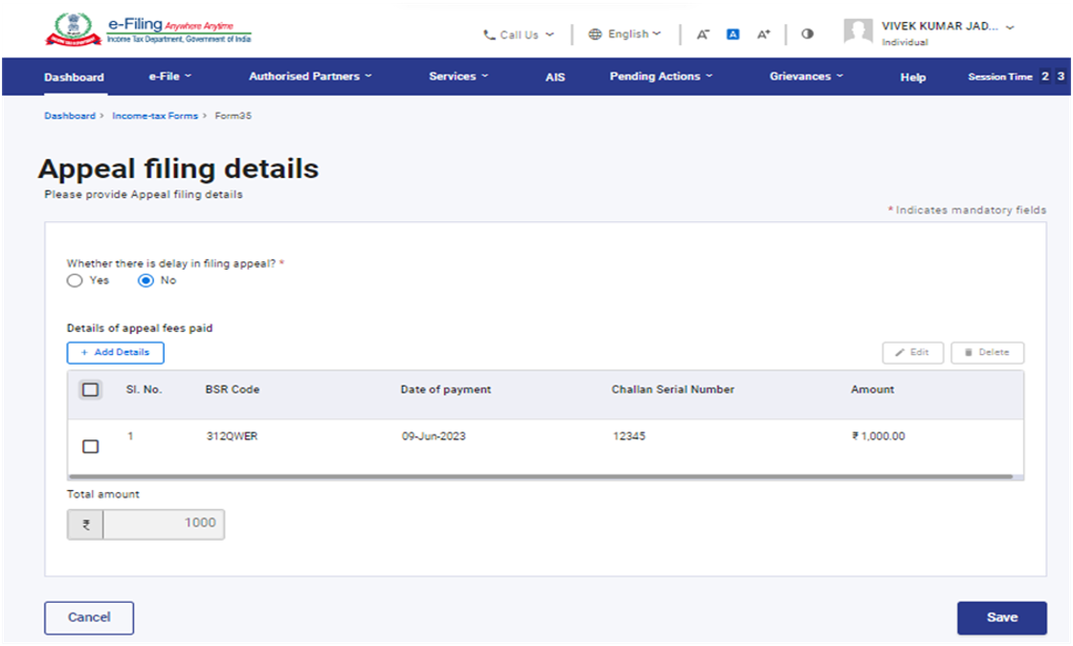

4.8 Attachments  
  
In this section, attach a copy of the order appealed against, and the notice of demand.

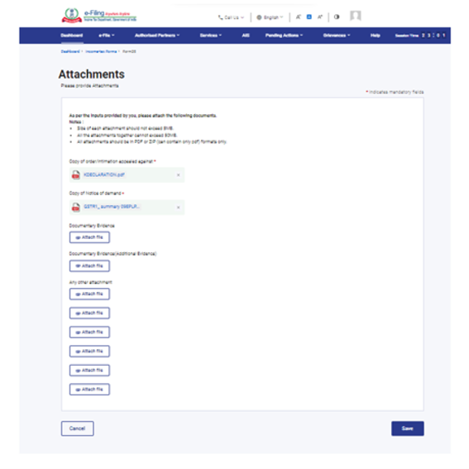

4.9 Form of Verification  
  
Form of Verification page is a declaration from the assessee filing Form 35.

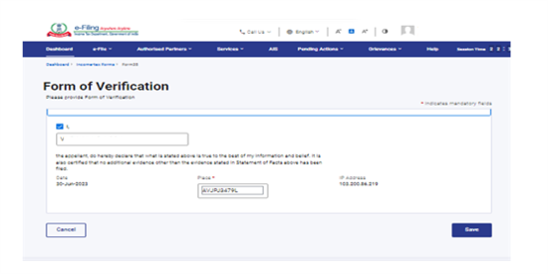

5. How to Access and Submit

You can fill and submit Form 35 through the following method:  
• Online Mode – through the e-Filing portal  
• Offline Mode – through the Offline Utility

Note: Refer to the Offline Utility (Statutory Forms) user manual to learn more.

Follow the below steps to fill and submit Form 35 through online mode.  
  
Step 1: Log in to the e-Filing portal using your user ID and password..

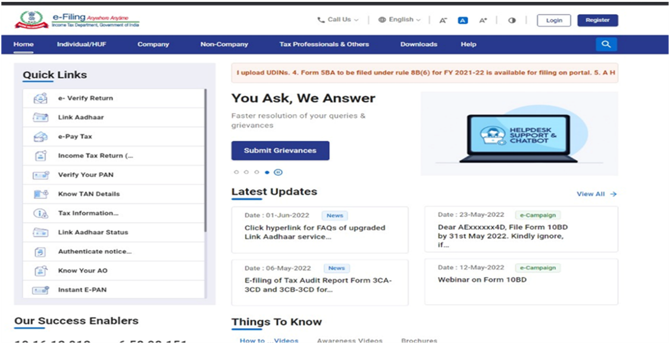

For Individual users, if PAN is not linked with the Aadhaar you will see a pop-up message that your PAN is made inoperative as it is not linked with your Aadhaar.   
To link the PAN with Aadhaar, click on Link Now button else click Continue.

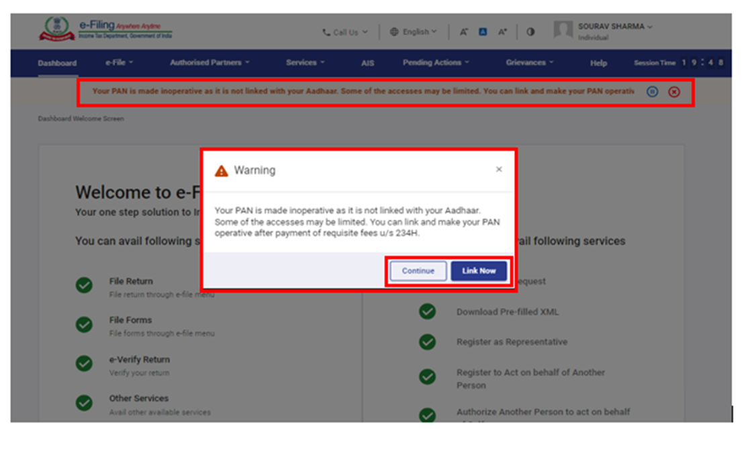

Step 2: On your Dashboard page, click e-File > Income Tax Forms > File Income Tax Forms..

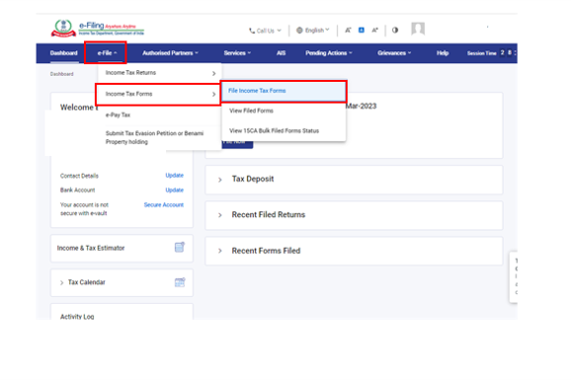

Step 3: On the File Income Tax Forms page, select Form 35. Alternatively, enter Form 35 in the search box to file the form.

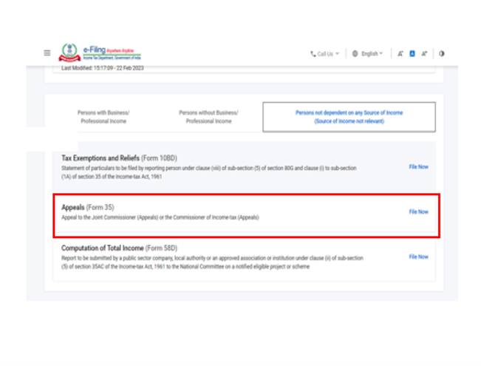

Step 4: Select the Assessment Year and click Continue.

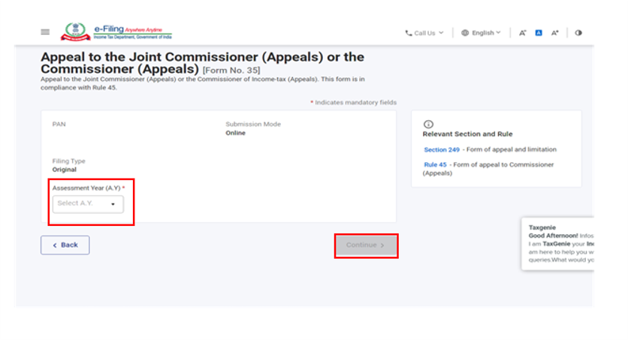

Step 5: On the Instructions page, click Let's Get Started.

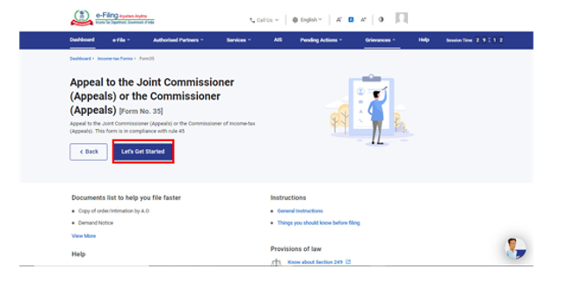

Step 6: Select the applicable order type:  
a. File Appeal for an order without DIN.  
b. File Appeal for an order with DIN (Order issued after 1st October 2019).

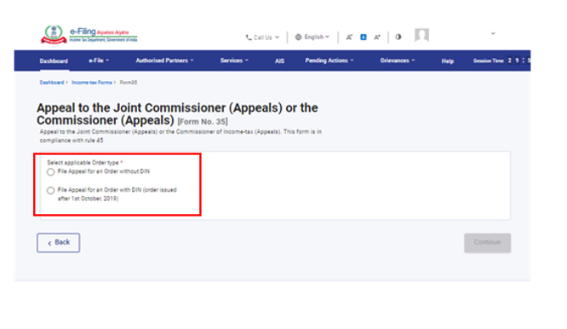

Step 6 (a): If you are selecting order type as File Appeal for an order without DIN, select Section and sub-section of the Income-tax Act, enter order no./DIN, Date of Order, Date of service of Order / Notice of Demand / Date of payment of tax in case of Appeal u/s 248.

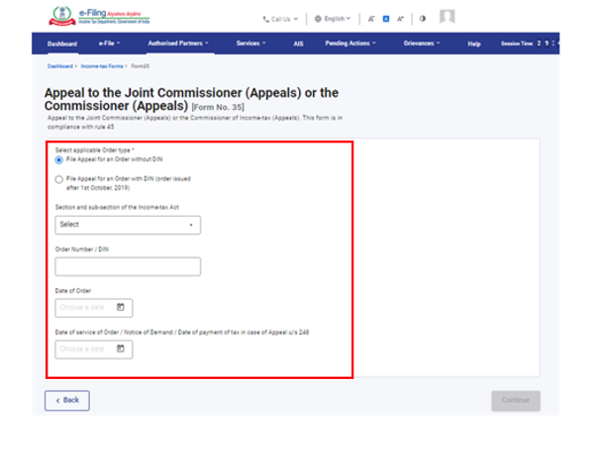

Step 6 (b): If you are selecting order type as File Appeal for an order with DIN (order issued after 1st October, 2019) select DIN of the Order against which Appeal is filed, Section and sub-section of the Income-tax Act, Date of Order, Date of service of Order / Notice of Demand / Date of payment of tax in case of Appeal u/s 248.

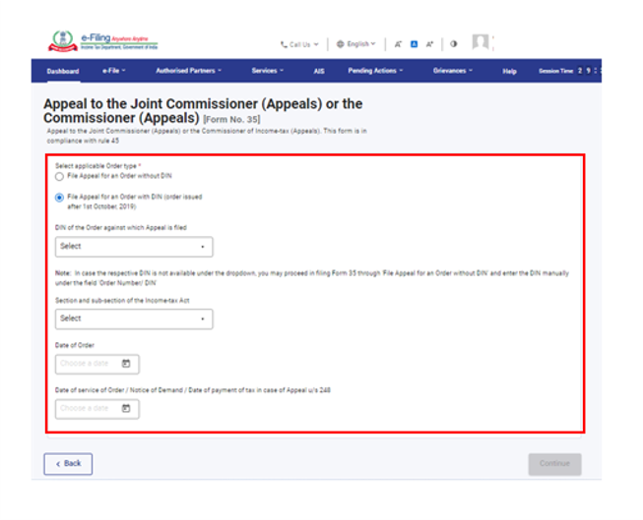

Step 7: Form 35 is displayed. Fill all the required details and click Preview.

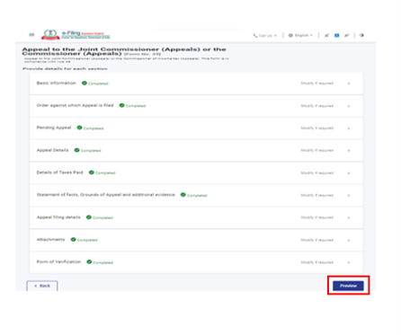

Step 8: On the Preview page, verify the details and click Proceed to e-Verify.

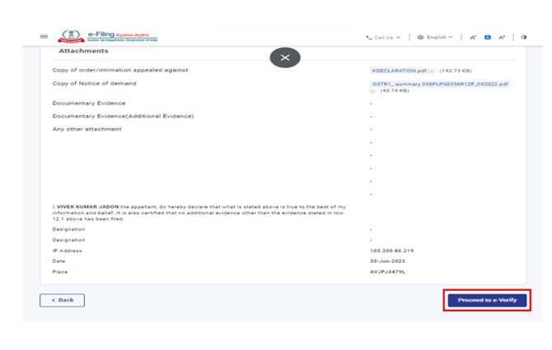

Step 9: Click Yes to submit.

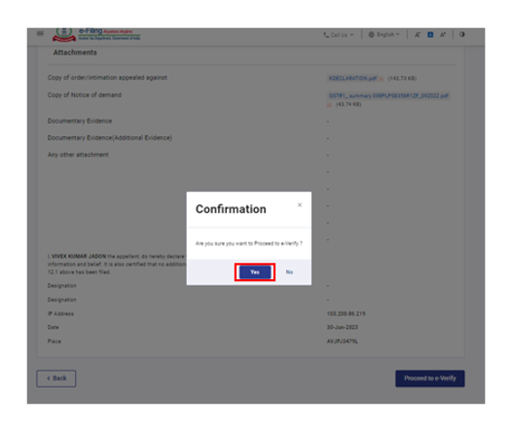

Step 10: On clicking Yes, you will be taken to the e-Verify page.

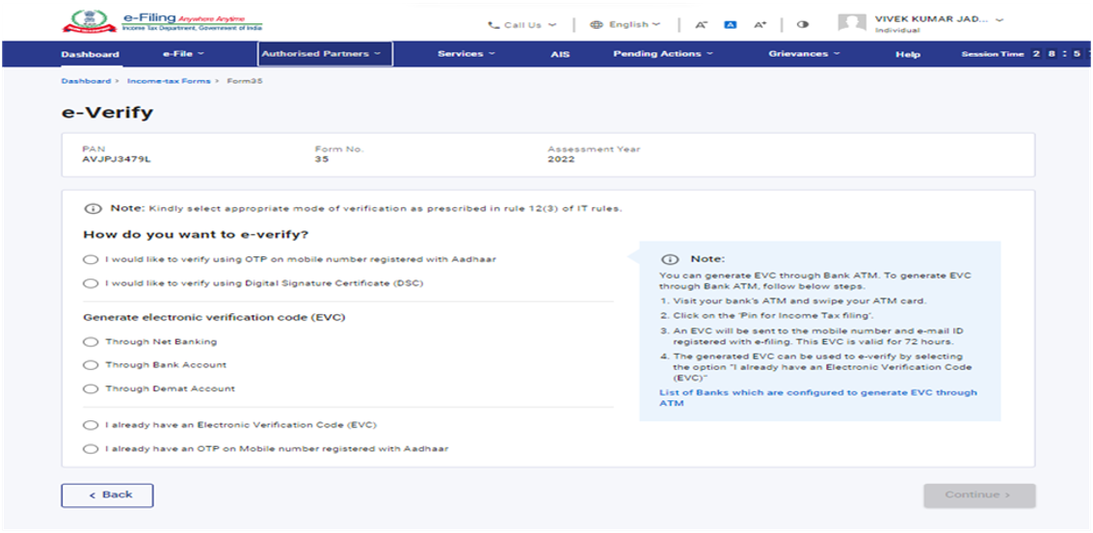

Note: If your PAN is inoperative, you will see a warning message in pop-up that PAN of the taxpayer is inoperative as it is not linked with Aadhaar.

You can link PAN with Aadhaar by clicking on Link Now option, otherwise click Continue.

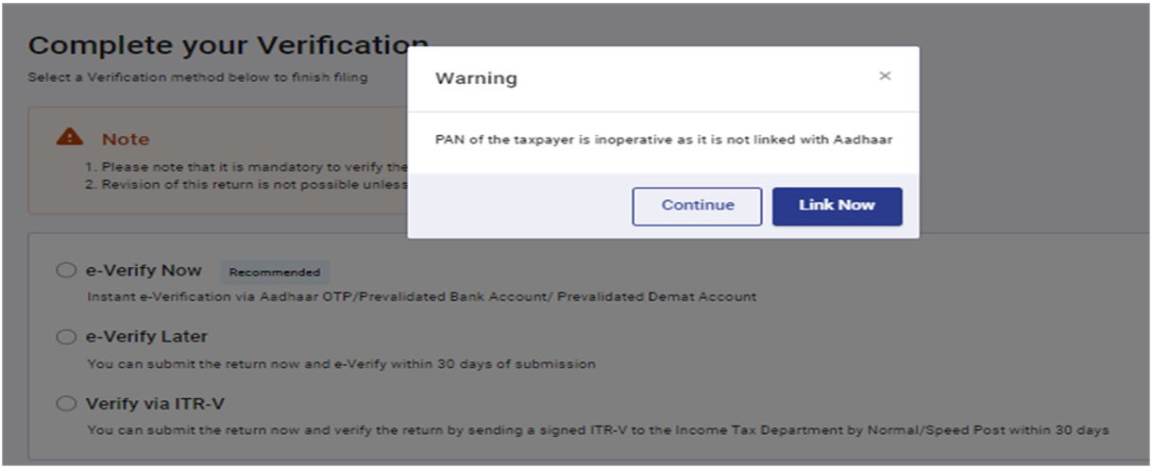

Note: Refer to the [How to e-Verify](https://www.incometax.gov.in/iec/foportal/help/statutory-forms/popular-form/url%5d/help/how-to-e-verify-your-e-filing-return) to learn more.

After successful e-Verification, a success message is displayed along with a Transaction ID and Acknowledgement Receipt Number. Please keep note of the Transaction ID and Acknowledgement Receipt Number for future reference. An email confirming successful submission of your form is sent to the email ID and mobile number registered with the e-Filing portal.

